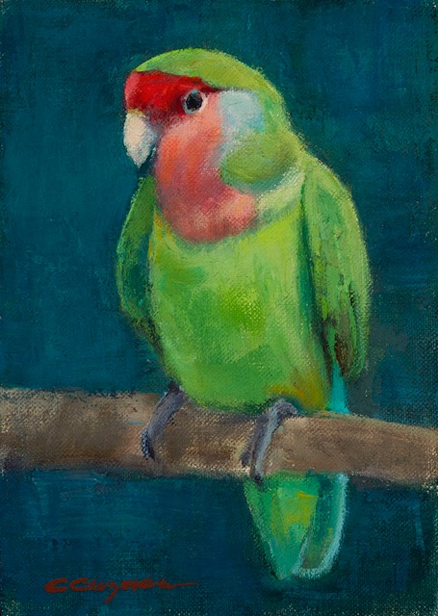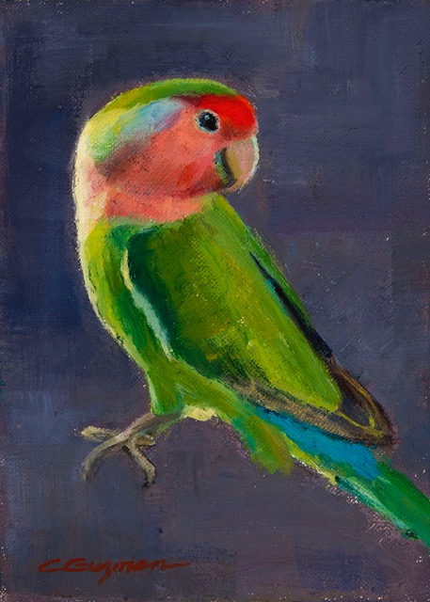
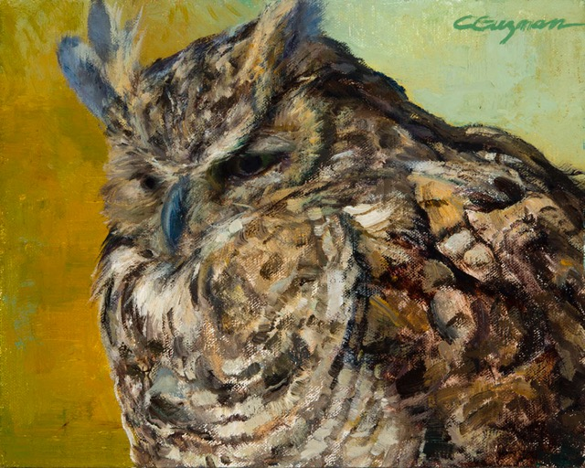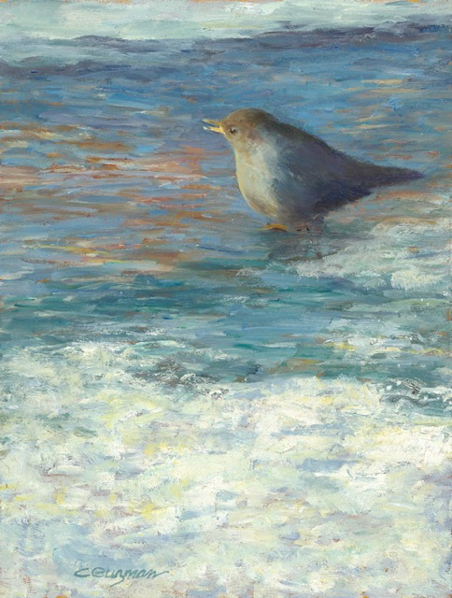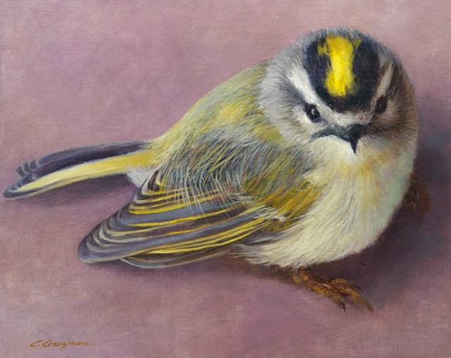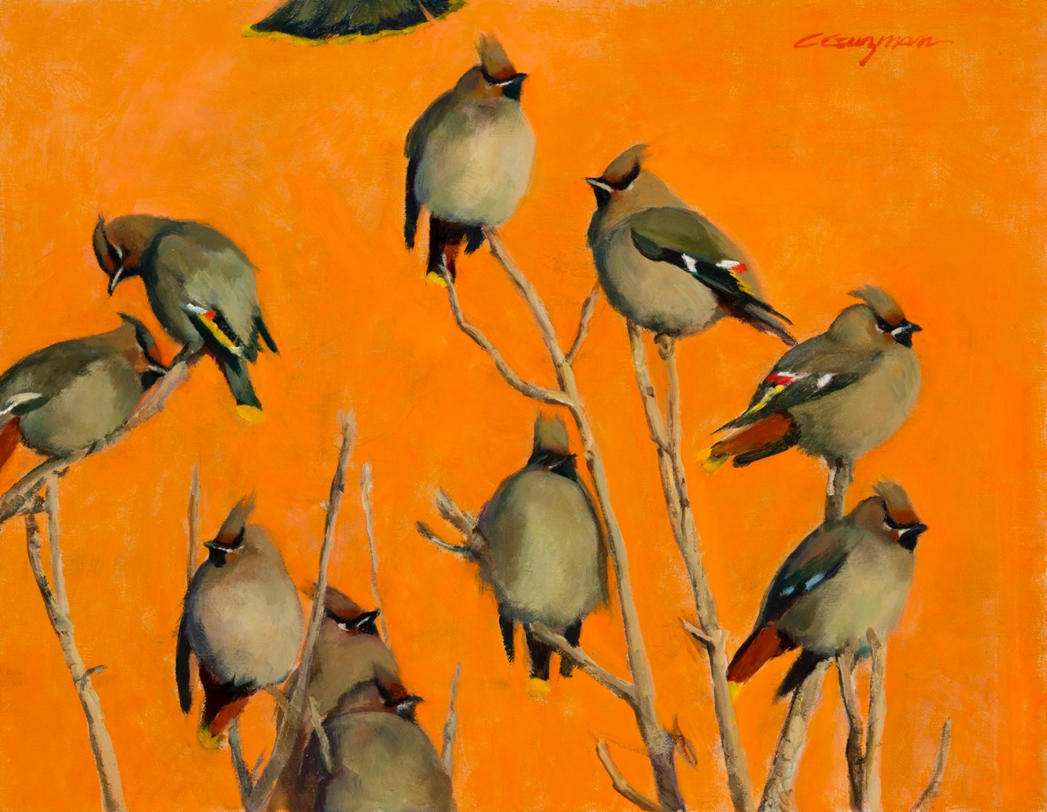
Carol Guzman
“Rosy-Faced Lovebirds #1”
“Rosy-Faced Lovebirds #2”
“Great Horned Owl Portrait”
“American Dipper”
“Golden Crowned Kinglet”
“Out on a Limb”

Drawing from traditional painting techniques, Carol’s oil paintings transcend alla prima painting. She prefers to paint in her studio and working over a period of time in layers creating visual texture and interest. Her subjects range from wildlife, still life, landscapes, florals and objects of interest including intriguing Native American artifacts and antique toys.

