We have designed this event to be as no-contact as possible. We encourage you to social distance, wash your hands frequently and wear your masks!

Responses, photos, and stories may be used on the East Helena Food/Culture Hub Facebook page and/or in a documentary film being created by the MAPS Media Institute.

The East Helena Food/Culture Hub is a community-fired creative placemaking project with major funding from ArtPlace America and support from The Myrna Loy, the Montana Environmental Trust Group, the City of East Helena and folks like you who call East Helena home.

The East Helena Food/Culture Hub brings East Helena residents together around food, culinary arts, and community events to inspire us all to plan and build a vibrant future for our town.

Adding to its history with the Stack Fest, the Harvest Fest & Apple Press, the Ribbon Project, the Mural Project, the restoration of the Star of David windows from the smelter and the architectural plans for the new community center at the Volunteer Fireman’s Hall, the East Helena Food/Culture Hub has created this scavenger hunt as another way for us all to have some community fun!

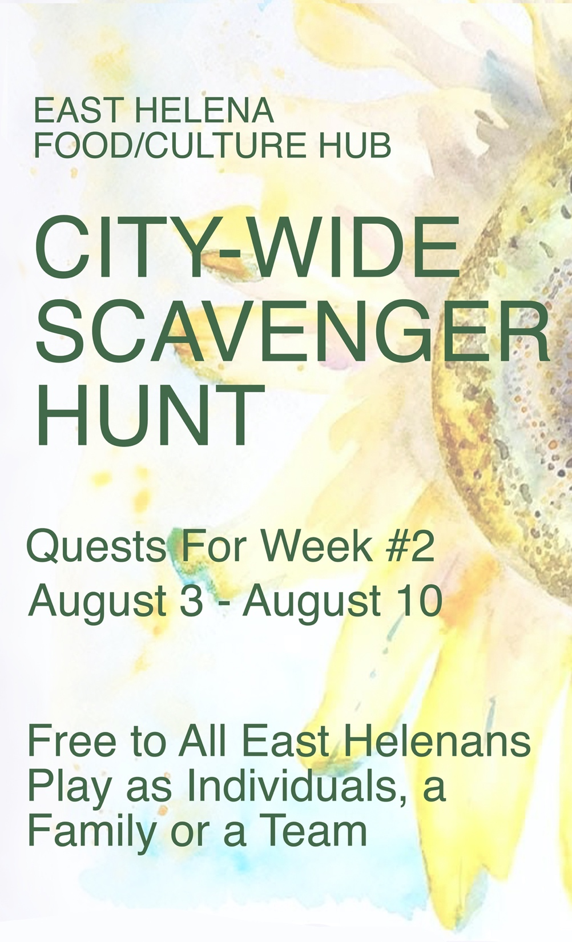
How well do you know East Helena, yourself or your family? Do you like to explore? Take selfies? Perform? Learn about East Helena history, its buildings and businesses? Hang out in its public and natural spaces?

The more you find and share, the more we learn about our town and each other. All quests are within East Helena city limits.

Play as an individual, a family or a team.

Play using the printed weekly quest found at the kiosk in front of City Hall, at the library, at the Volunteer Fireman’s Hall sunflower murals or the digital list on the East Helena Food/Culture Hub Facebook page.

Prizes! Complete three or more of each week’s quests and collect an artist-designed prize!

Play each or any week of the four-week hunt!
Hunt #1: Monday July 27th – Monday, August 3rd
Hunt #2: Monday August 3rd – Monday, August 10th
Hunt #3: Monday, August 10th – Monday, August 17th
Hunt #4: Monday, August 17th – Monday, August 24th

Your answers can be collected as writing, drawings, printed
out photos, photocopies . . . whatever works for you!

Place your responses in an envelope (don’t forget your name and contact info!) in the City Hall drop box by noon on the final Monday of each hunt week. Submissions will be tallied and prizes will be available for pick up by all those who complete at least three of each week’s quests at City Hall by Wednesday. Each qualifying family or team member will receive a prize. And, don’t forget to pick up the next week’s quests!

QUESTS FOR WEEK #2
(choose and complete 3 or more)

COMMUNITY #4
Take a photo of Mayor Jamie, print it out.

COMMUNITY #5
Is there someone in East Helena who is a hero to you? Write a brief story about them.

ONLINE QUEST #1
Go to the East Helena Food/Culture Hub Facebook page and post something you like about East Helena. Print a copy of your post.

ONLINE QUEST #2
Upload a photo/video or write a memory of the East Helena Food & Culture Hub’s Stack Fest from 2019 on the East Helena Food/Culture Hub’s Facebook page. Print a copy of your post.

NATURE AND PUBLIC SPACES #1
Sketch or take a photo of your favorite place in Main Street Park.

BUSINESSES AND BUILDINGS #2
Take a photo of you researching something in the library or have a librarian write a note saying you did it.

HISTORY #2
Make a rubbing of something historical – a sign, the texture of an old building, a headstone at the cemetery - with pencil or crayon on paper.

YOU AND YOUR FAMILY #3
Briefly describe an action or activity by you or your family that makes you proud.

