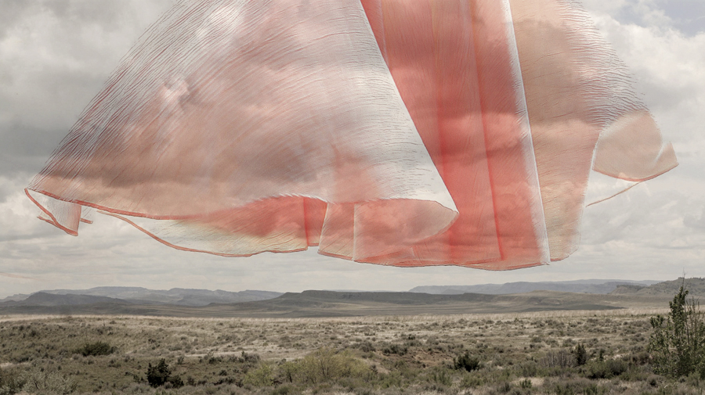

Jean Albus
“Pink Cloud”

It acts on the mind in some strange way, this dress, this terrain. It forces the mind to coalesce two seemingly contradictory concepts. The physical presence of the empty dress hovering ghostly above the empty landscape sparks a palpable sensation of absence. It makes us feel the lack of something that ought to be there, but isn't. It is, in a way, like experiencing a kiss on the wrist of an amputated arm.

For a year now, Jean Albus has been most beautifully unsettling our minds with this dress—this series of dresses. There is meaning in these images, though the meaning may shift with the prairie wind. She has openly revealed the existence of a secret, but the nature of the secret itself remains hidden. This is her secret, though she generously shares with us a tantalizing glimpse.

Looking at these photographs, I feel both hollow and warm. I feel a pleasure woven out of sorrow. I feel a beauty born of loss. And most of all, I feel a sort of strength—as if the harsh terrain has lent its power to that delicate dress, and I sense that the dress will survive for as long as the prairie continues to exist

Greg Fallis, Utata Photography

