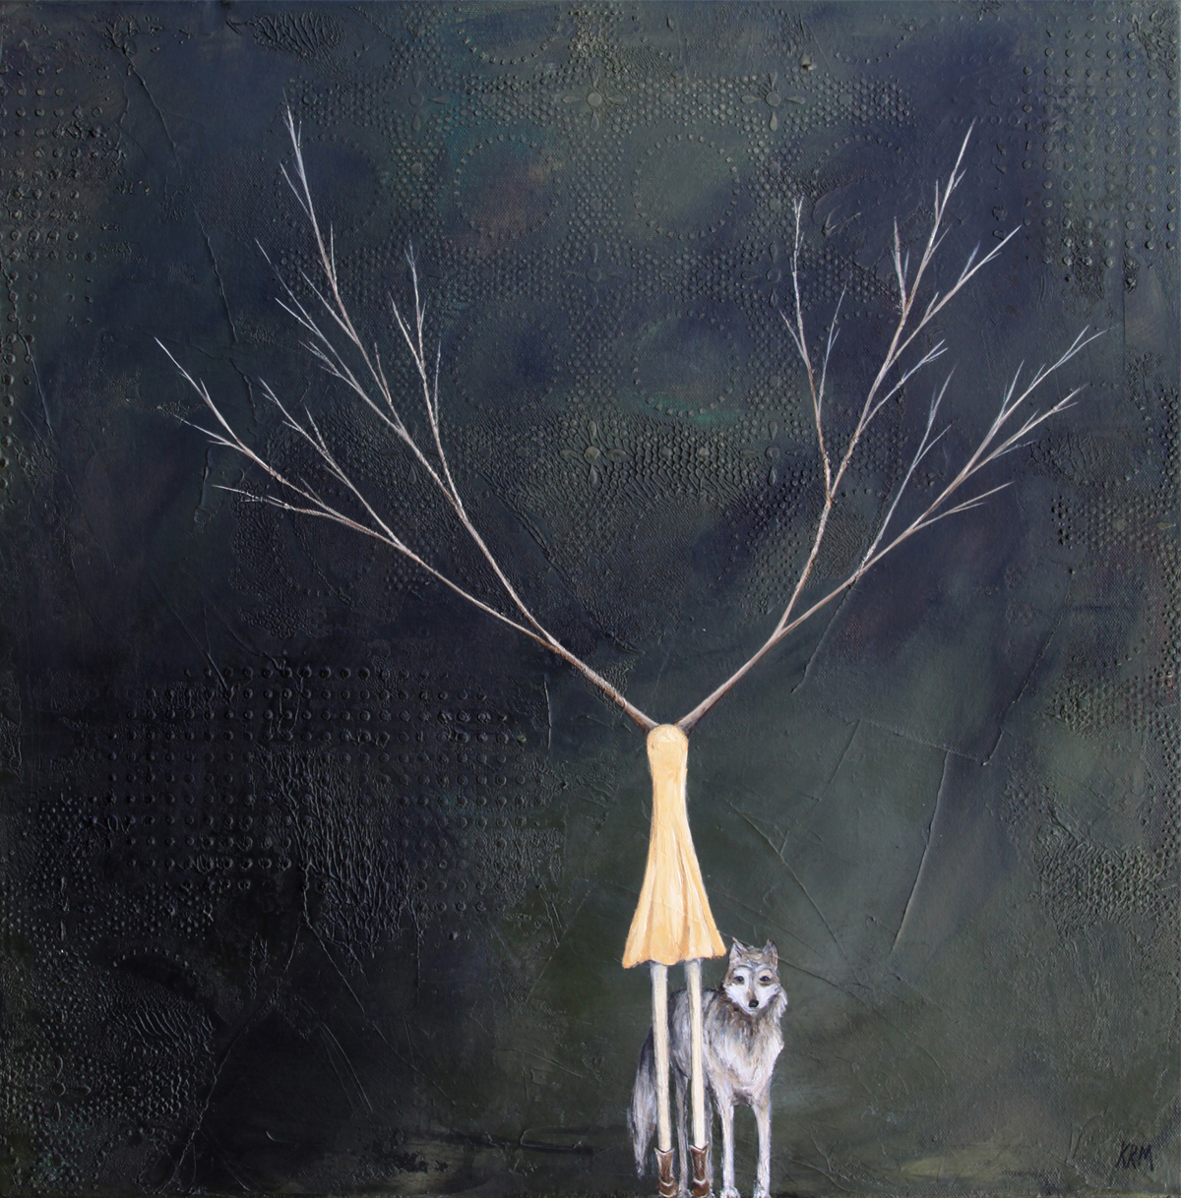
Kelsey McDonnell
“Shelter Me”

I use the female tree figures in my art as symbolic figures for concepts, feelings, and ideas. I have always felt a great connection with trees and the female form. I am constantly exploring new concepts and trying to find ways to express them through my art. -Kelsey R. McDonnell, 2015

