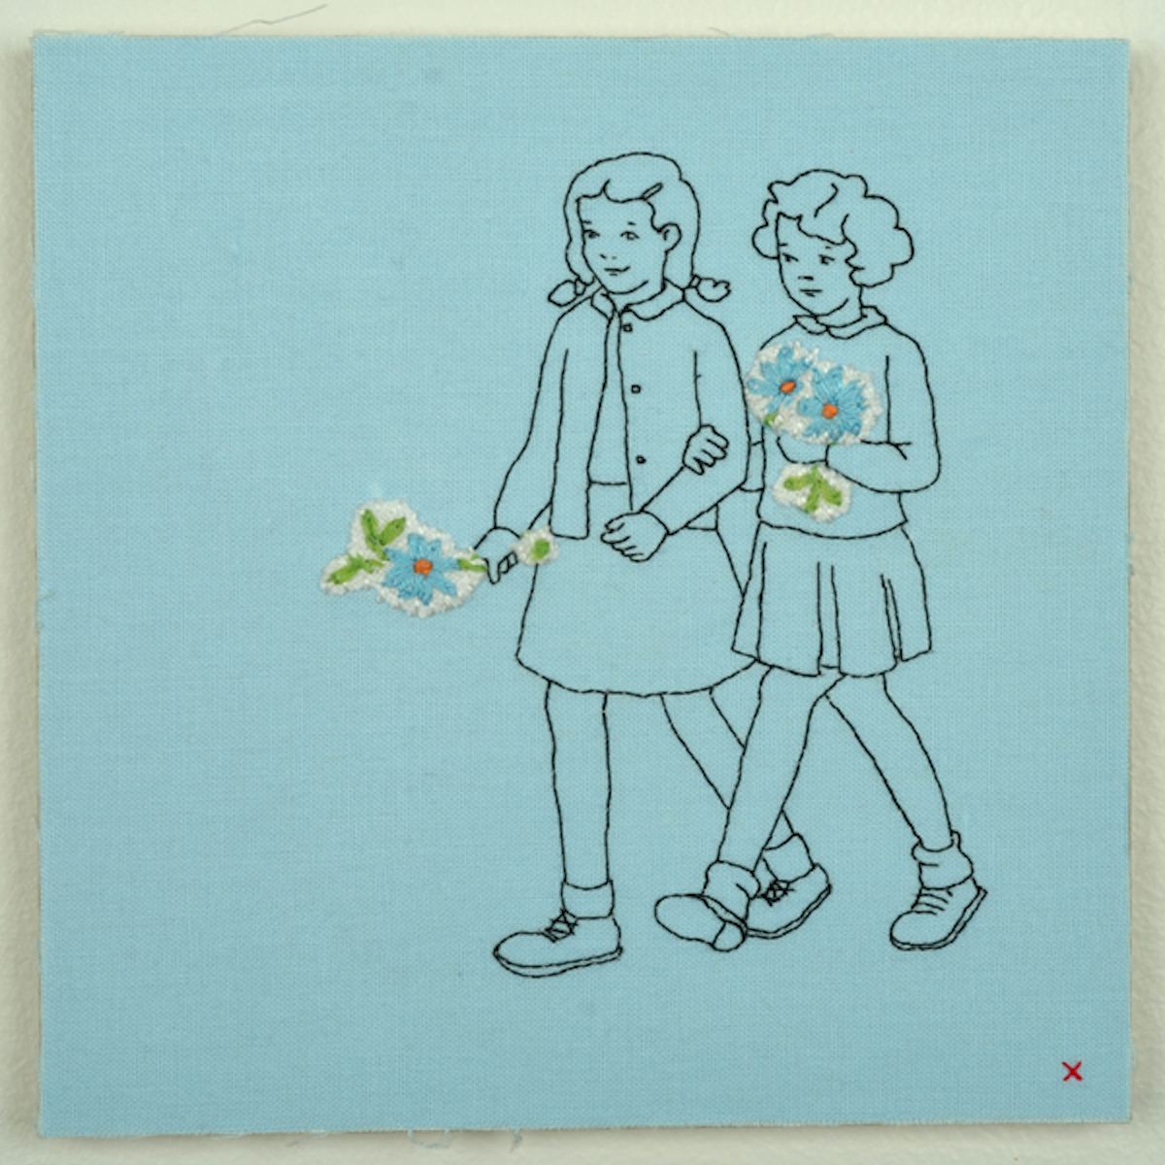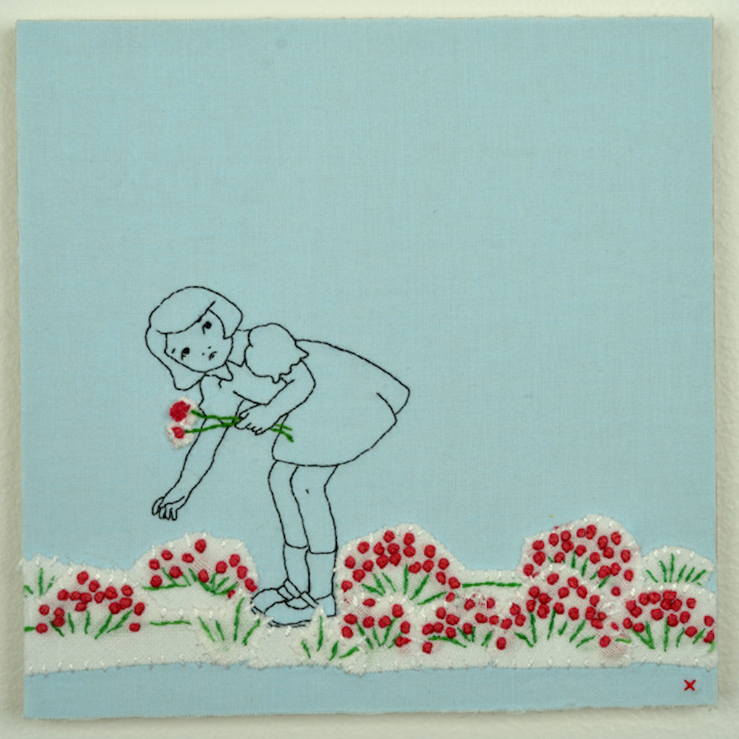
Maggy Rozycki Hiltner
“Flower Girls”
“Red Flowers”

One of my favorite activities when visiting a new city is to scour the antique shops for embroidery. I collect mainly flowers and foliage and am especially drawn to the odd anthropomorphic animals and household objects. There’s a sadness to antique shops, and for me, especially in the embroidery---the many hours that were devoted to stitching these now discarded treasures. I like to think that in using these found bits and pieces in my work, I’m giving them a new life, a way to be precious once more.

And I’m fascinated by how memory works. Why do some scenes and stories stick and others are only vaguely available to me? Why are some of my most recurring memories so emotionally charged while others are thoroughly mundane. I’ve found that in recreating these moments in my work, they change in how I hold them in my mind. My hope is that if the image I’ve created feels true, it will transmute for the viewer, evoke a recognition in them. Our anxieties, insecurities, joys and pains are oddly common.

‘Is it autobiography if parts of it are not true? Is it fiction if parts of it are?’---Lynda Barry

I try to create images that at first appear whimsical or vibrantly happy but on closer inspection are not quite so. Sometimes it’s a malicious undertone to the relationships, or a lack of self-control on the part of the characters, or maybe an otherworldlyness hidden in the everyday. I like how this subtext works against the comfortable and innocuous medium of fabric and stitching.

