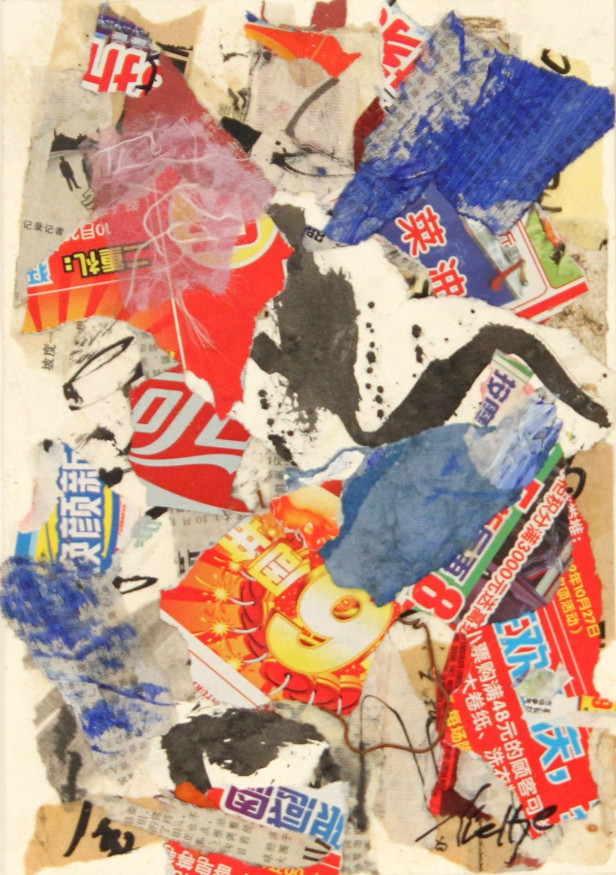

Neltje
“Wednesday”
h
Neltje is gatherer of art and objects that touch her heart or tell a story, so the objects in the house range from a rusty old trike, to a Debbie Butterfield “Bluebell to shelves of Asian newspapers, chopstick covers, torn pieces of her own artwork, artisain papers. The trike whispers that it was new and shiny and the wheels rolled effortlessly and the wind ran through a child’s hair as the “wee’s” flew up like scattering birds. Debbie Butterfield’s horse “Bluebell,” head is slightly turned and she is just about ready to step out of the paddock. The shelves of stuff whisper possibilities of texture, color and shape. All she has to do is glue them together according to a plan that is a secret even to Neltje until she finally lets the glue sets and says, "There."

