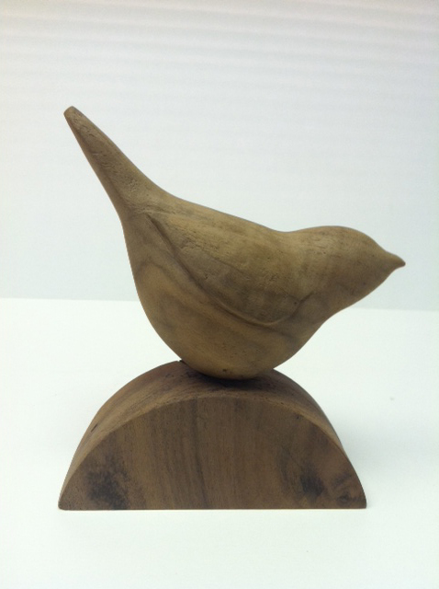
Phoebe Knapp
“Bird”

I like to work primarily in wood because it has life, history, and radiates warmth. It is a difficult material to obtain, living in eastern Montana, and is subject to checking, especially as I do not usually laminate, but carve and saw into entire logs or large chunks of wood. It is a living, flawed material, however, with it’s own energies and forces and helps the sculptures take on a life of their own.

