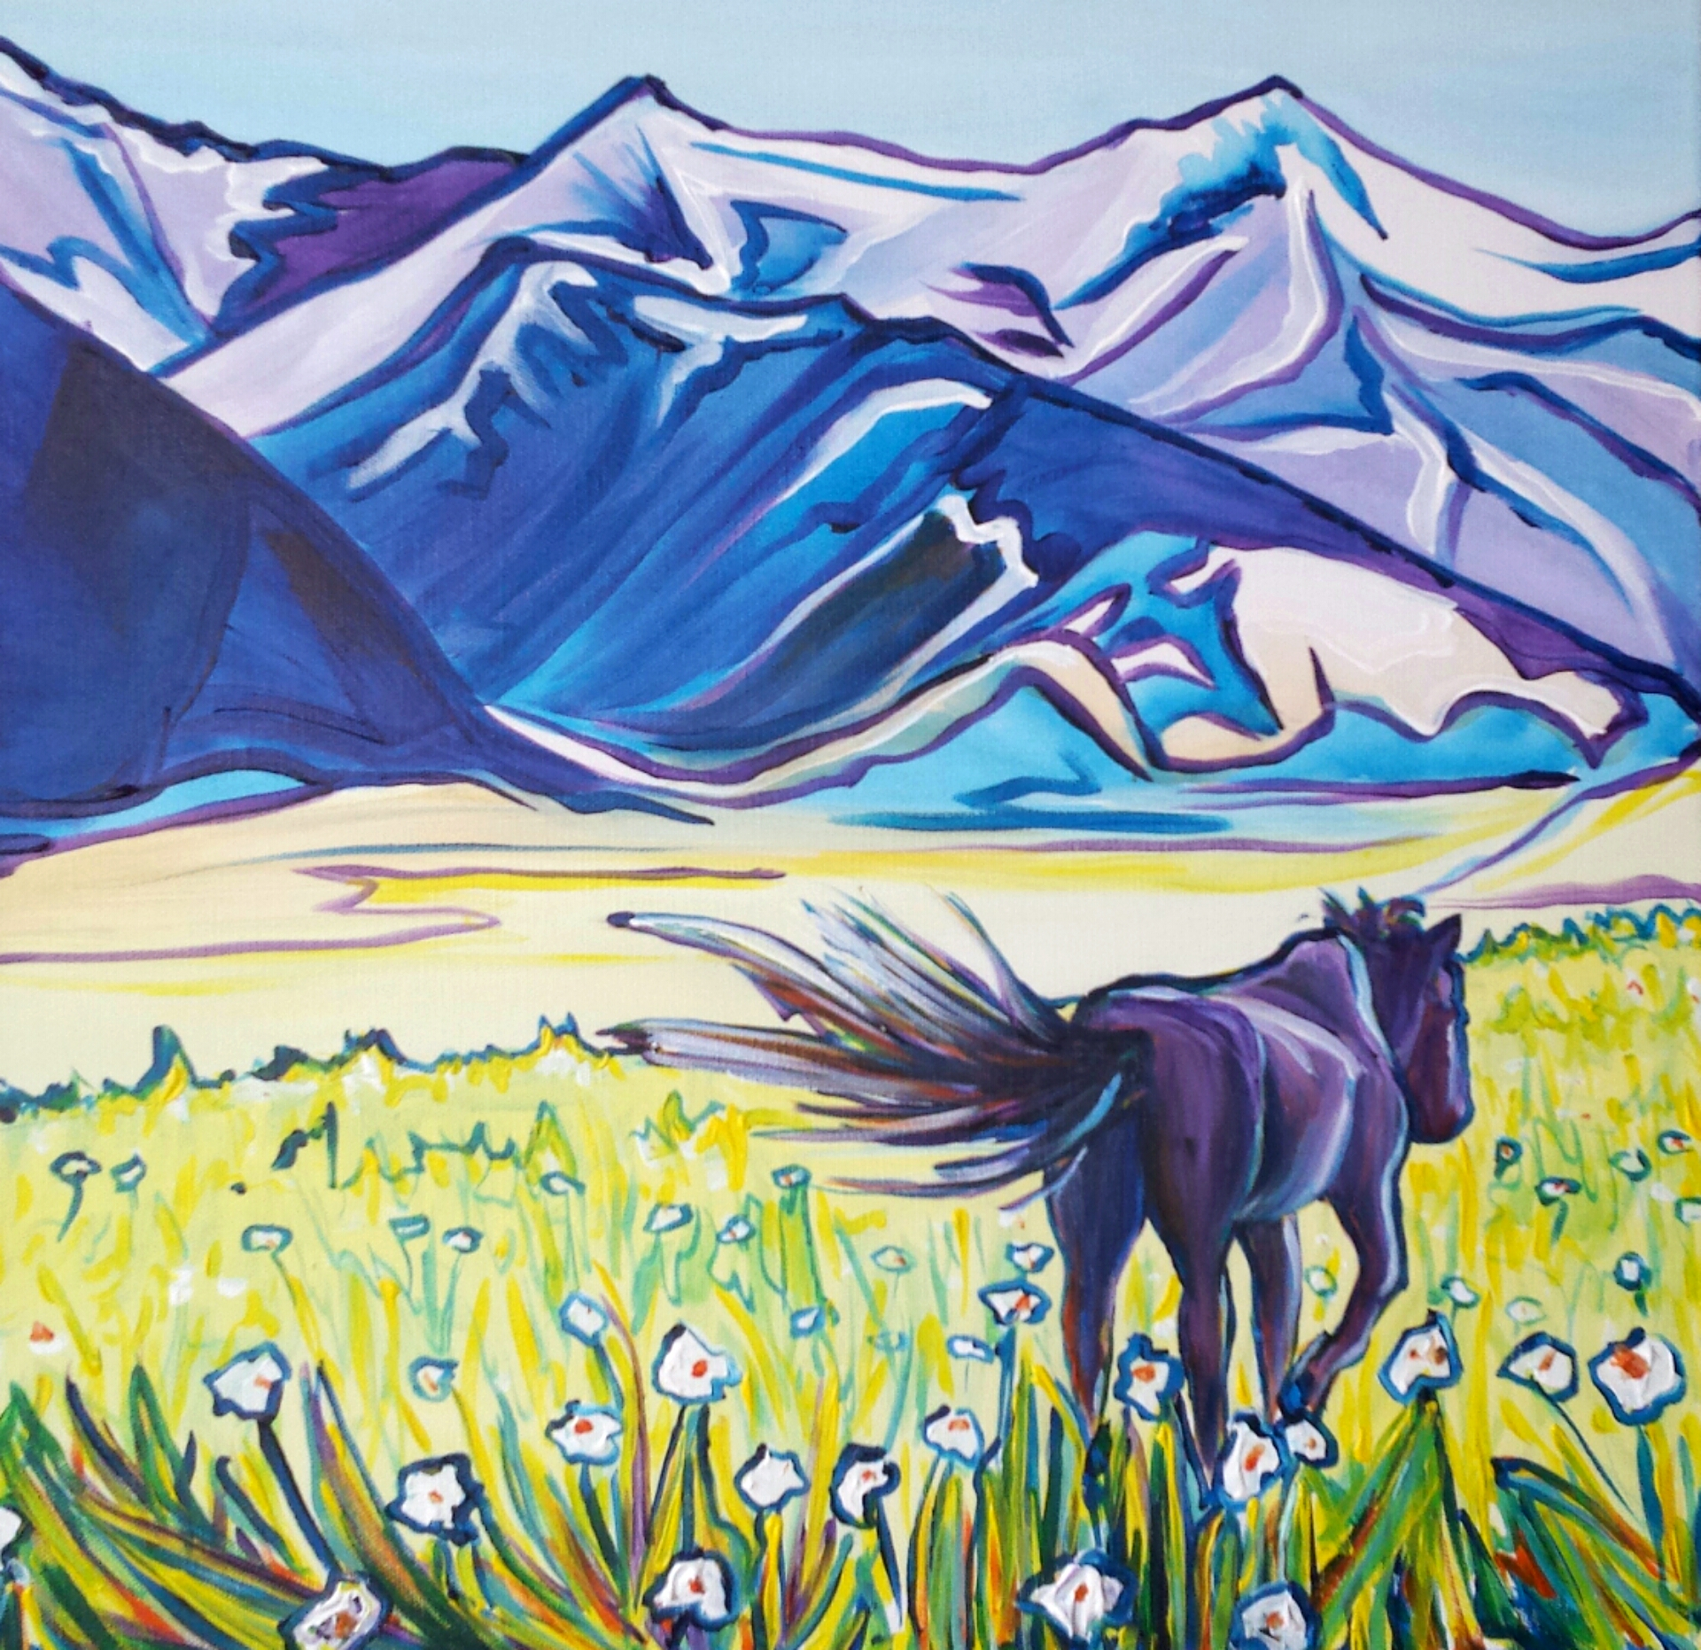
Sarah Morris
“Introverted”

I've spent years looking out at the endless miles of visibility in this "Last Best Place." The layered clouds in the sky, miles of rolling hills, dramatic mountain ranges, and countless points of view to experience keep our eyes dripping with pleasure. I used to obsess with what it looked like before man inhabited the west. What emotion Lewis and Clark must have felt when they first saw the wide open beauty of what I now call home. Knowing all of this pavement won't be going anywhere, I knew I had to learn to appreciate the aesthetic qualities of civilization. Many of these scenes are familiar to Montana residents. In fact many of us see these views of Montana more than we see the parts that are still left with out roads, fences, and cattle guards. As you view my art, I hope you experience the feeling of your last road trip, hike, camping trip, or even the feeling of being a Montanan, because it is a beautiful feeling to posses.

