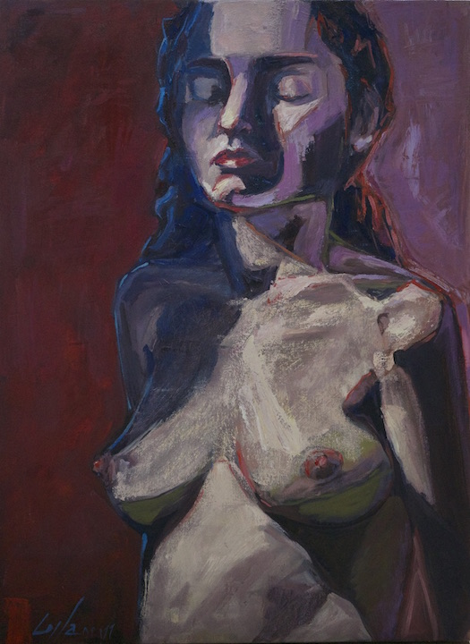

Coila Evans
“Electric Introspect”

Round-up based artist, Coila Evans, recently participated in a residency in New York City to train under Iliya Mirochnik.

