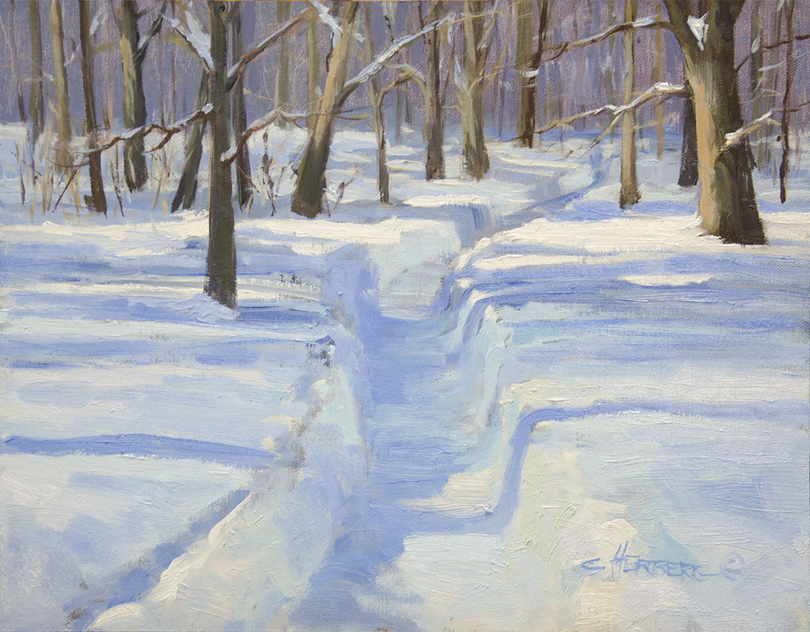

Connie Herberg
“A Walk Through Winter Woods”

I am a landscape artist, painting and living in the middle of my dream subject matter here in Montana. This "Big Sky Country" serves as a source of inspiration daily. The vast blue skies coupled with prairies, mountains and landscapes continue to be a source of awe. My passion is fulfilled as I get to paint and live in this amazing western lifestyle.

