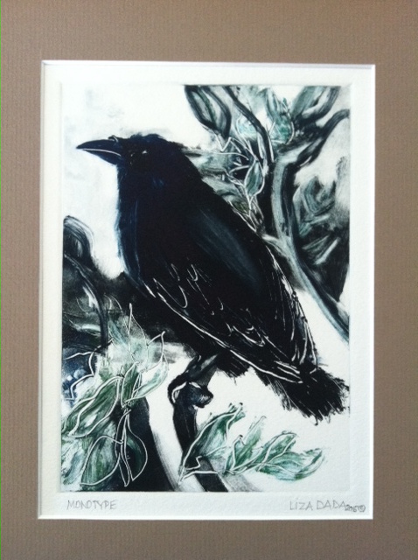

Liza Dada

“Raven Reckoning”

“I am connected to life by art. I believe in the nurturing power of beauty and affirm that creating something “beautiful” is a responsible effect of social conscience that works to emphasize hope, build self-esteem, diminish anxiety and reject guilt. Art drive me.

