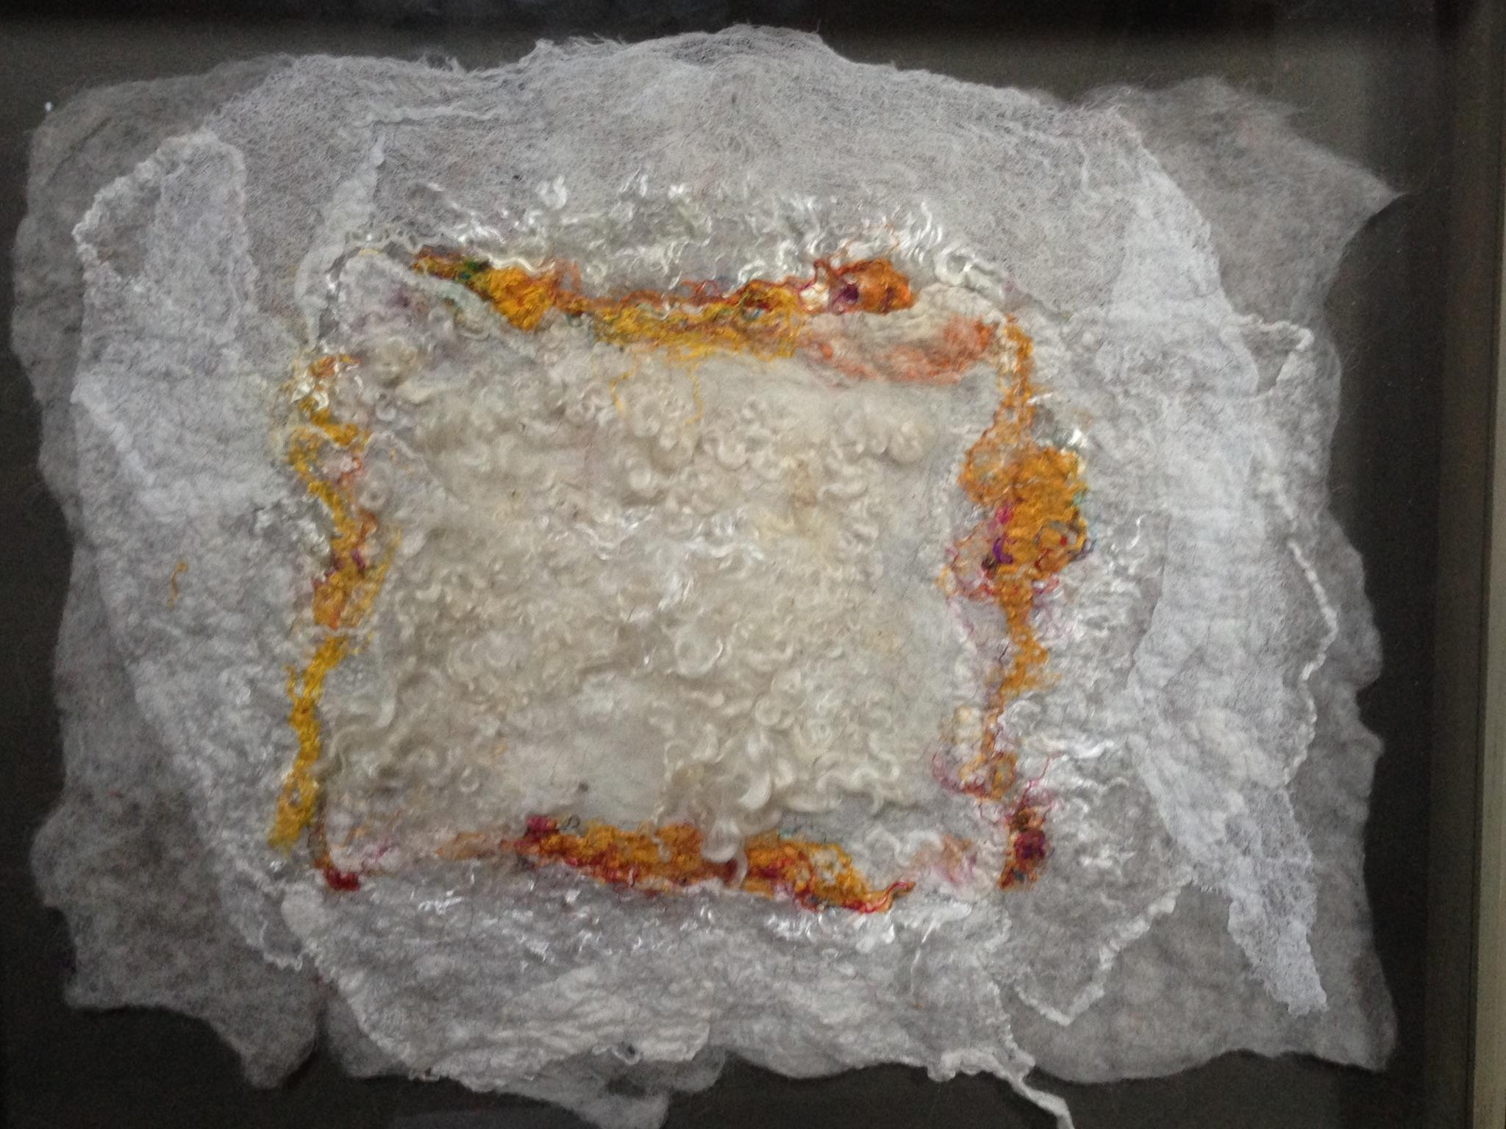
Robin Taylor
“Locks”

I create to entertain myself and to satisfy that incessant itch to compete with the natural world to make something beautiful and interesting and pleasing. I create with wool and other natural fibers because they are beautiful, interesting, pleasing and nearly impossible to taint with my clumsy explorations. Felting is a utilitarian craft dating back thousands of years. The first time somebody put a tuft of wool in their sandals to smooth a blister, then walked and sweated a couple of miles up the road, they had felt – a durable, water resistant, breathable, wondrous fabric. Incorporating silk, hemp, tencel, ramie and gauze is an endlessly fun and fascinating bonus.

