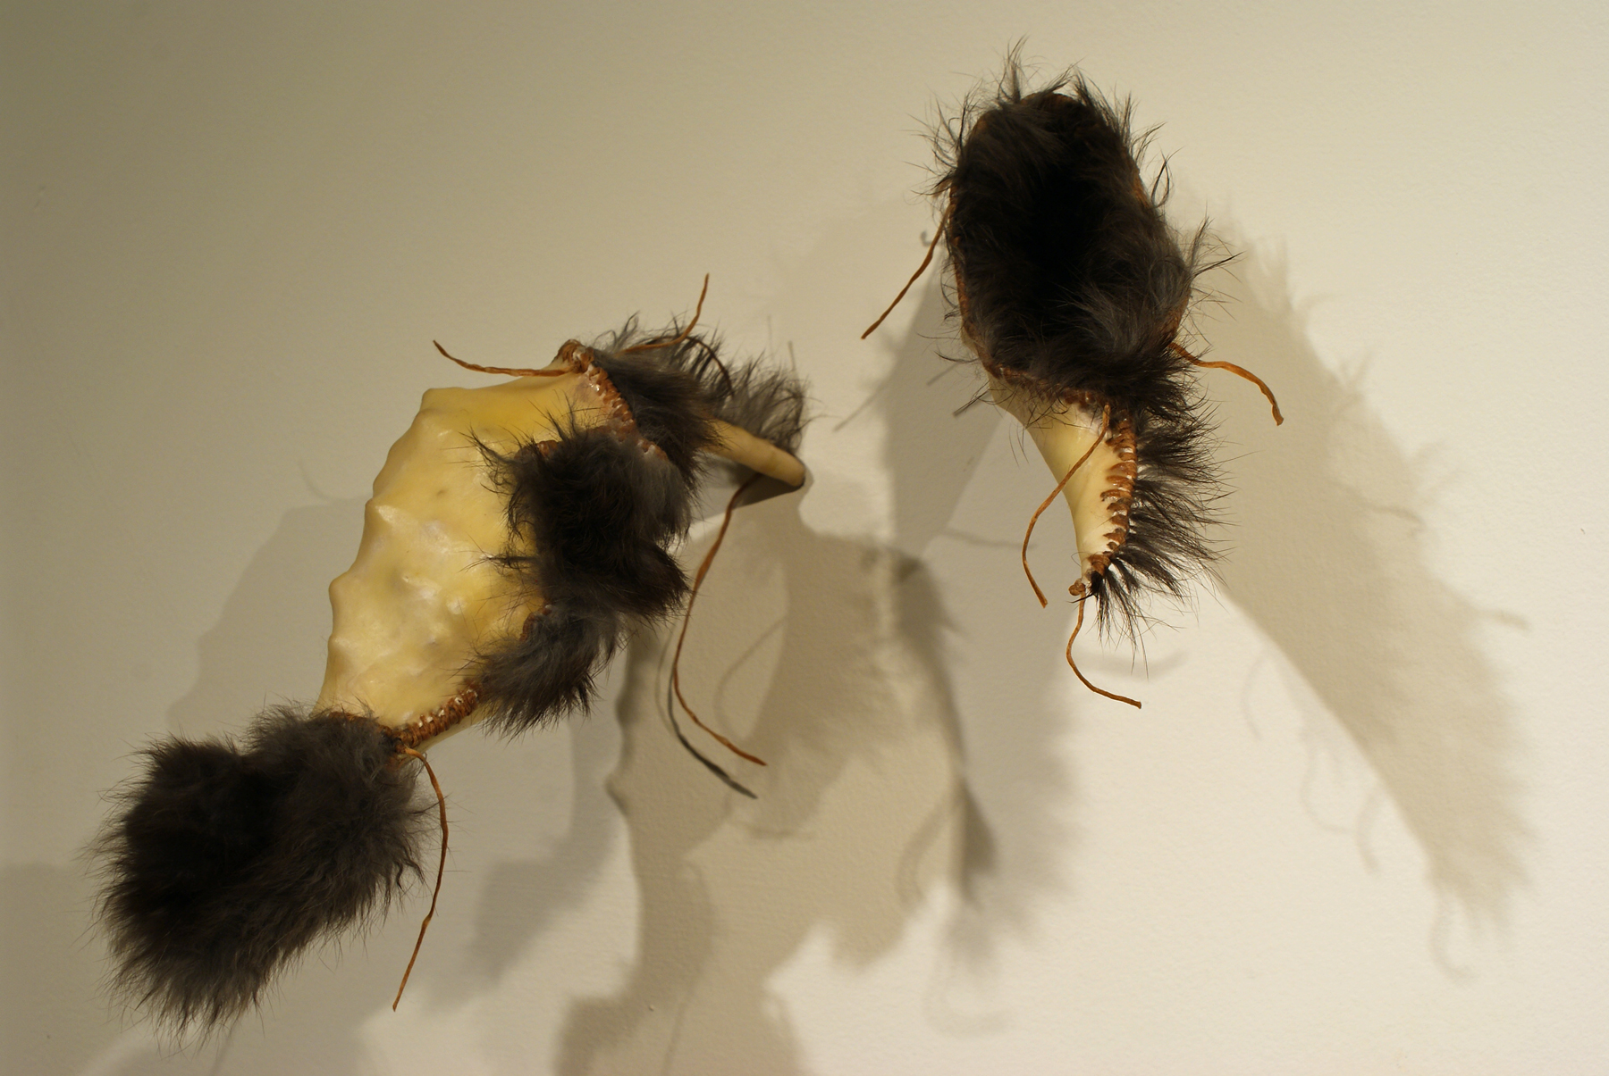
Tracy Linder
“The Sowers: Seed Pods”

The Sowers: Seed Pods series is looking at the different ways seeds are distributed in order for survival. Based on milk pods which open to distribute seeds in the wind, they have offered a warm insulated womb for gestation. The use of animal flesh is to consider the interdependent relationships necessary for survival. Showing the vulnerability and survival skills of plants and animals has long been a concern in my studio practice and is part of my ongoing exploration.

quick facts/anecdotes about milkweed:
Milkweed is exceptionally important to the Monarch Butterflies. Several concerned groups now give away milkweed seeds for people to grow as Monarch populations are in decline.
During WWII, due to lack of feathered down, milkweed was raised by farmers for pillow stuffing. (I believe the remnants of that time are why we see milkweed in our gutters and ditch banks as it is not a native species here)

