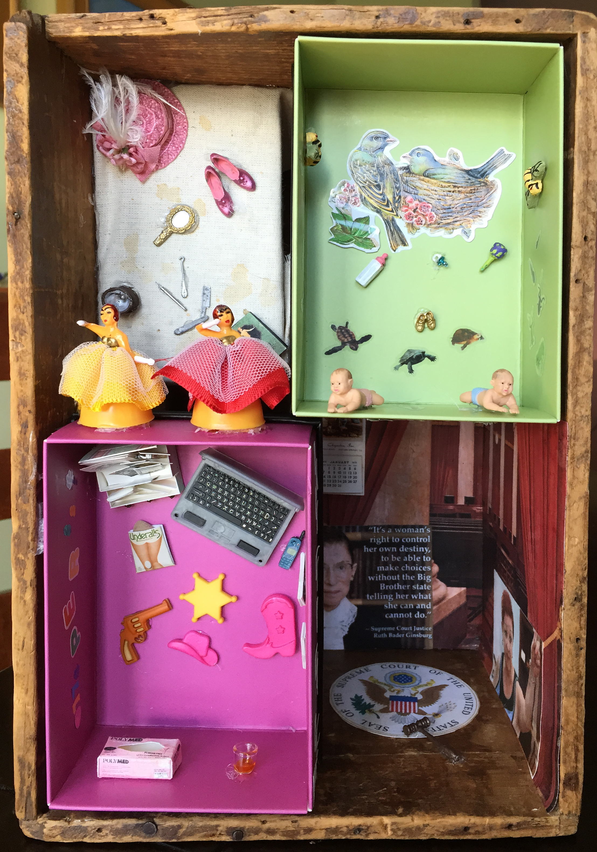

Abigail Hornik
“Give me a Gun and a Badge”

I am influenced by Joseph Cornell and Robert Rauschenberg. Both cultural and personal memories inform my work. I love working in miniature and creating tiny worlds giving the viewer a voyeuristic experience. Hopefully, they will discover new things each time they look. I try and have a little bit of a sense of humor too.

