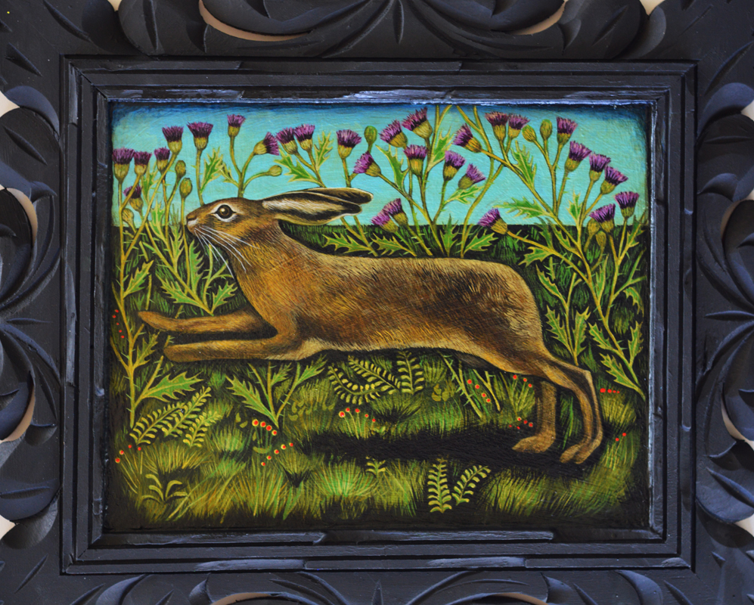

Jennifer Eli French
“Hare and Thistles”

My paintings begin as vintage framed art culled from thrift stores and yard sales. Gesso and collage is applied directly over the existing images, followed by monochromatic under painting and multiple layers of glazing. I incorporate found objects into my work as a catalyst to consider personal and collective memory. Imagery is drawn from my family’s history and common narratives like fairy tales and folk songs.
I am inspired by medieval art, the Western landscapes of my childhood and the strange beauty I find in the darker corners of history.
I always return to the image of the rabbit. They appeal to me both aesthetically and as symbols of birth and femininity, and my neighborhood here in Billings is filled with them!

