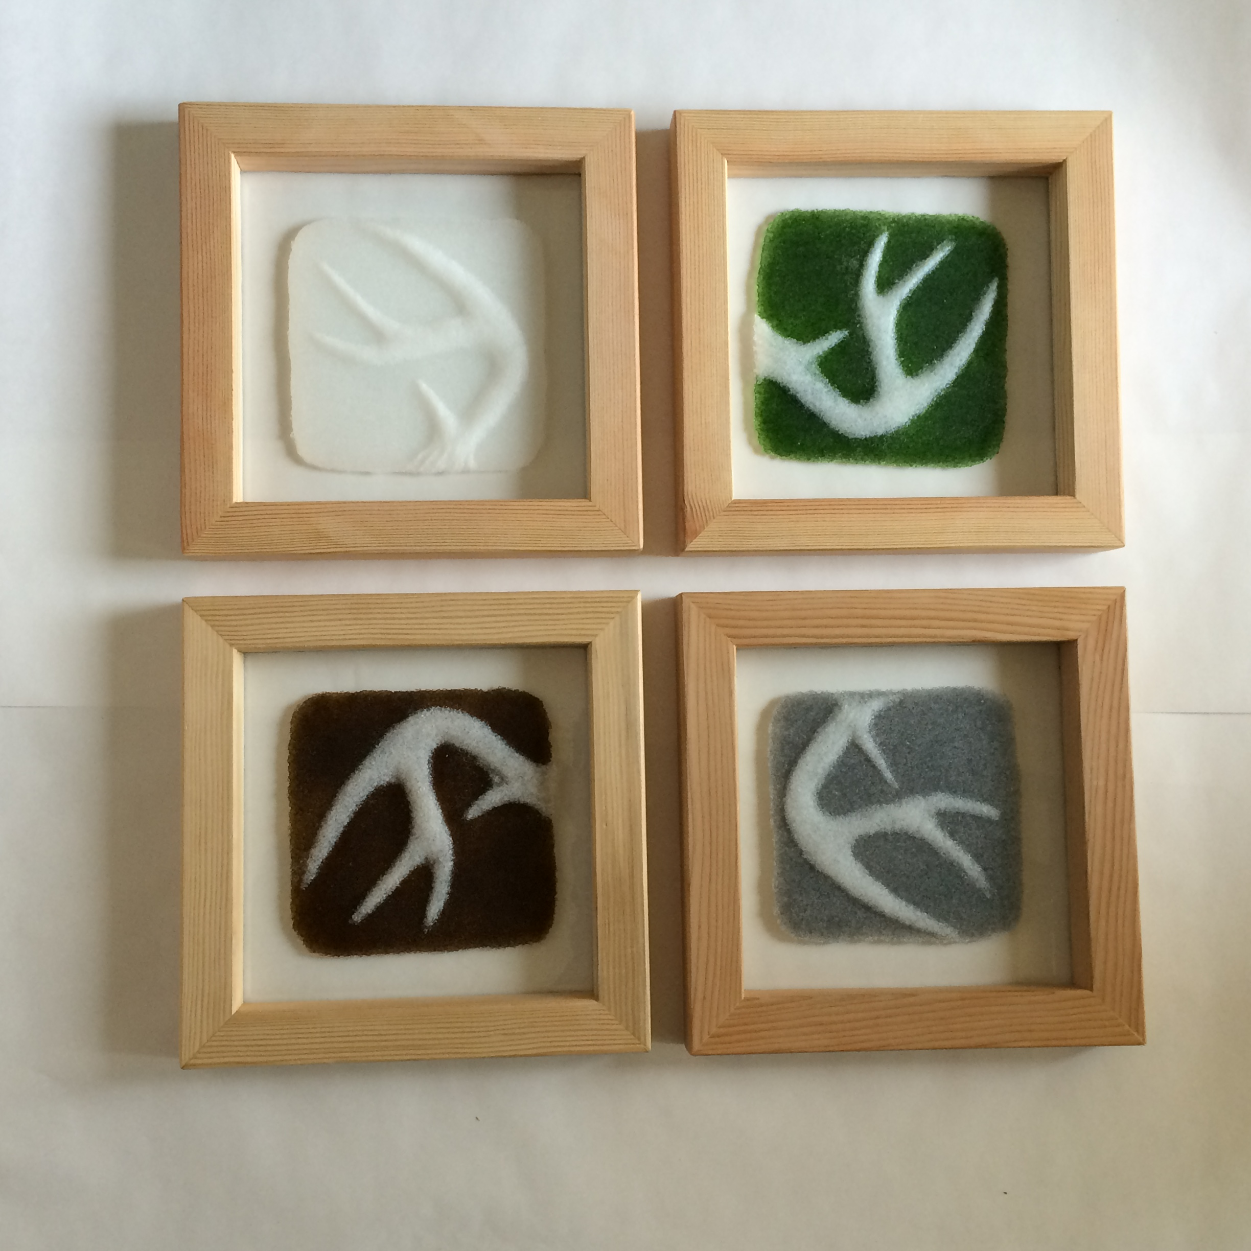
Kate Morris
“Prairie Series”

The Pate de Verre process involved is lengthy, but the product has a light, airy feel due to the medium of glass. The images used are reactions to thoughts that rattle around my brain and reactions to the land I have northwest of Great Falls, Montana.

