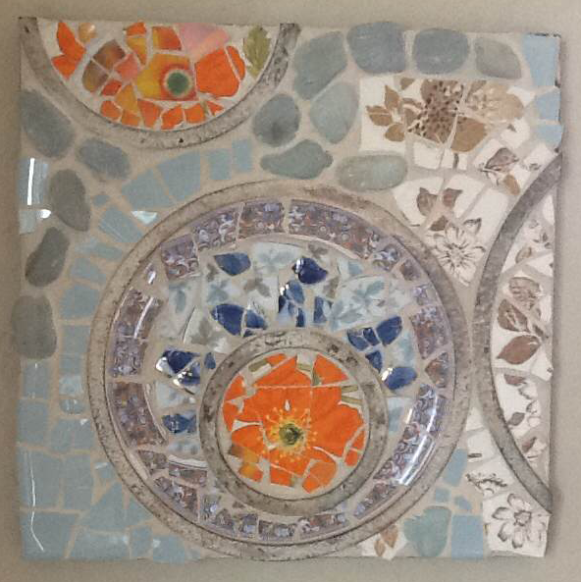
Linda Lemire
“Beach Poppies”

My mosaic work is a commitment to the re-use, repurpose, and reincarnation of objects discarded, abandoned, flawed or forgotten. I primarily use dishes and tile while integrating stained glass, mirrors, metal and tidbits of nature. My mosaics weave creativity with functionality, nature with human-created, whimsical with pensiveness, old with recent. I like the overall medium of mosaic because, like life, it provides renewed possibilities and surprising outcomes.

