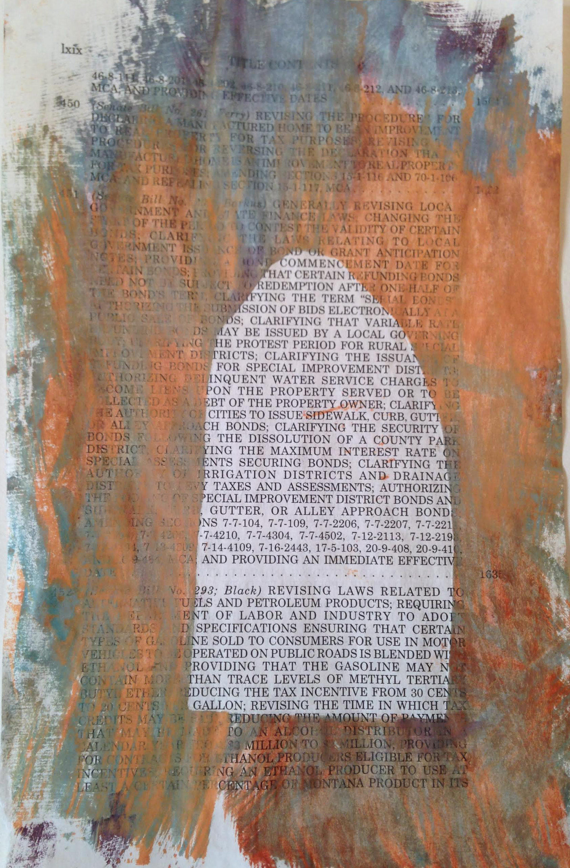
Lynda Moss
“Here”

Here is a small monotype painting on a page from a volume of law books from my first session in the Montana legislature. It is part of a series that includes universal images of crosses ovals, veils, dots and dashes. These shapes are like music scores. They record hours and days, thousands of voices, volumes of records and perspectives from a place and time far removed from our day-to-day lives.

