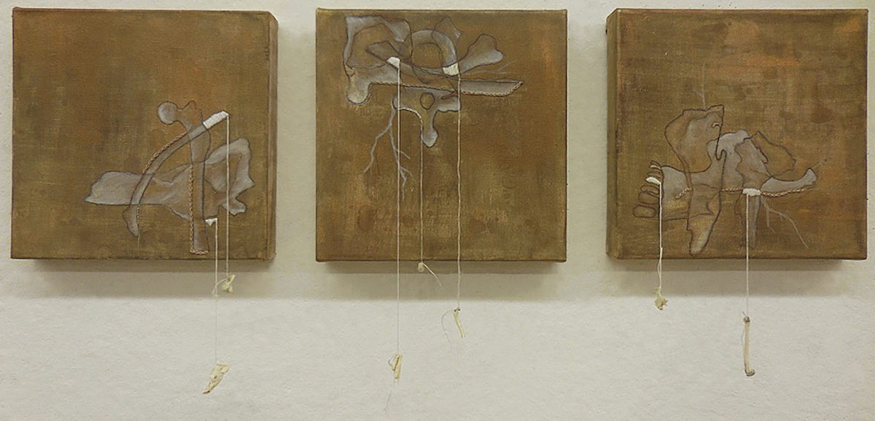
Samantha French
“Atrophy”

My artwork examines the inner word versus the external in an objective, nonlinguistic method. The work is rooted in a visceral experience with materials, texture and form. As I work instinctively, I think of these works as documentations of a meditative process. Each piece follows the haphazard, sometimes seemingly disjointed paths of the mind, vacillating between conscious and intuitive creation. I intent for my artworks to provide context for the psyche, the objectivity of time and space, the chaotic nature of our modern world, and people’s internalized anxieties, fears and compulsions.

