Anosognosia and the Asymptote
By Sherri Cornett
(As published in “Beyond Borders: Stories of im/Migration” exhibition catalog, Gutfreund Cornett Art, 2017, ISBN: 198342787X)

The decree [the summary Executive Order of a Member State prohibiting migration from seven selected countries with Muslim majorities], which was arbitrarily and summarily enforced, is clearly in violation of several of the UN Conventions prohibiting discrimination on the basis of religion, nationality or race . . . It is an arbitrary, xenophobic, profoundly harmful act which in its disregard for promises, its violation of fundamental and dearly cherished human rights and humane values diminishes us all. It creates division, demonizes and stigmatizes as potential terrorist a particular group of people on the sole basis of their religion, ethnicity, and national origin. It sows fear, suspicion and instability everywhere.
Maria Pia Belloni-­‐Mignatti, Chair, UN NGO Committee on Migration¹

How did we get here, where science, facts and truths are undermined? Where divisiveness and hate are escalating? How are our opinions and views of our world, and those with whom we disagree, created? Where do we go for reliable answers to our questions? How do we know what we know? What we don’t know?

The United States was built on the foundation of intellectual freedom. The Fairness Doctrine of 1949, which was abolished in 1986, created an “honest, equitable and balanced” presentation of issues in broadcast news. As a result, accurate media content could help with the development of our personal viewpoints. With the advent of an Internet model that creates a proliferation of unsubstantiated facts, the devaluation of investigative journalism became a reality. With the negation of science, the standard of truth became destabilized, leading Stephen Colbert to coin the word “truthiness” If one feels it is true in one’s gut, it must be true, despite what “elitist” reference books might prove otherwise. ²
“Forbidden is any kind of search for truth that is not in conformance with accepted practices . . .” Andre Breton, The Surrealist Manifesto³
Every man has a right to his own opinion, but no man has a right to be wrong in his facts. Bernard Baruch January 6, 1950 issue of the Deming (New Mexico) Headlight

In his five part series The Anosognosic’s Dilemma, author Errol Morris talked with author and professor of social psychology David Dunning about imperfection of insight.

“What we see and what we hear” is shaped by our preferences, our wishes, our fears, our desires and so forth. We literally see the world the way we want to see it. But the Dunning-­‐Kruger Effect [as coined by Dunning and his research partner Justin Kruger] suggests that there is a problem beyond that. Even if you are the most honest, impartial person that you could be, you would still have a problem – namely, when your knowledge or expertise is imperfect, you really don’t know it. Left to your own devices, you just don’t know it. We’re not very good at knowing what we don’t know.”⁴
Morris and Dunning go on to equate this phenomenon with anosognosia, which is a neurological term used to describe someone who has a disability, but does not know he or she is disabled. Applied to the broader world, there are things we know we do not know. For these, we can research and find answers, or we can deny that we do not know. We can choose to stop being curious and stop learning. We can create barriers around our beliefs while simultaneously ignoring those that do not agree with us.

Why Can't We All Just Get Along? Robert Wright, in his article The Uncertain Biological Basis of Morality, calls this confirmation
bias. “Some of our deepest moral intuitions are gut feelings that are with us for no more lofty a reason than that they helped our ancestors protect themselves and spread their genes.”⁵ What happens when we do not know that we do not know; when we don’t know our inabilities, our disabilities, and/or our ignorance? Wright says, “self-­‐doubt can be the first step to moral improvement.”⁶
When it comes to understanding something as emotionally, socially, morally, politically and legally complex as the issues surrounding migration, immigration, assimilation and deportation, self-­‐doubt and curiosity are our first steps. No matter how much we aim to understand, we can never truly empathize or truly share the depth and breadth of someone’s experience. Each is unique and different.

And these differences are fortified by beliefs stemming from influential and dominant social constructs which reinforce combativeness and superiority.

“We are better than them.”
“Our religious beliefs are more true.”
“Our right to live in this country is more valid.” “Our race is more pure.”
“Our history is more important.”
“Our contributions are more meaningful.”

In our professional sports, athletic spirit reinforces this superiority, emasculates and dehumanizes the rivals as less than and increases aggression and protection of ‘us’ or ‘ours’. The creation of symbolic and real borders (sidelines, state lines, immigration filters) limits interaction and opportunities for finding commonalities.

Asymptote, /ˈasɪm(p)təʊt/ A straight line that continually approaches a given curve but does not meet it at any finite distance. Mid 17th century: from modern Latin asymptota (linea) ‘(line) not meeting’, from Greek asumptōtos ‘not falling together’, from a-­‐ ‘not’ + sun ‘together’ + ptōtos ‘apt to fall’ (from piptein ‘to fall’)⁷
There is no Occam’s razor, no simplest theory or observation that explains the personal, multidimensional realities of migration, immigration, assimilation and deportation. We can start by asking the following questions:

“What made you leave?” “How did you leave?”
“What did you take with you?”
“What it is like to be isolated from that which you had previously known?” “What do you fear?”
“What happened when you arrived?”
“What do you need to know to move forward?” “How do you protect yourself?”
“What do you know? What do you not know?” “Do you know what you do not know?

As with an asymptote, our aim and goal to fully understand will never quite reach nor comprehend the curve that makes up
the full spectrum of individual experiences. In the absence of clarity, we act irrationally, unevenly, and sometimes inhumanely. We often fail to see the real world consequences or the effects on individuals, children, adolescents, adults and families.

Breaking through Anosognosia

Errol Morris also interviewed neuroscientist V. S. Ramachandran, who, among many things, is known for his use of mirror-­‐ boxes in the treatment of phantom limb syndrome. The mirror image helps the patient’s brain reconcile the phantom pain with the visual of the missing limb, thus alleviating some of the discomfort. Ramachandran talked about layered belief, “that some part the brain can believe something and some other part of the brain can believe the opposite (or deny that belief)...We are overshadowed by a nimbus of ideas. There is our physical reality and then there is our conception of ourselves, our self.” ⁸
The concept of a luminous cloud or nimbus that surrounds us and creates magical thinking or fantastical beliefs is one example of the many ways we deceive ourselves. The mirror-­‐box analogy is also applicable. As Dunning believes, “The road to self-­‐ insight really runs through other people,”⁹ people holding mirrors up to our misperceptions. We need our media, academia, family and friends to give us that balanced, measured constructive criticism.

Of course, one has to be open to such feedback and be willing to take a broader view. The consideration of the interests and concerns of others and knowing that the steps one takes or the decisions one makes may affect someone else’s welfare, comfort, happiness, health are important aspects to weigh as we reformulate our beliefs.

Myths and Realities

The stream of untruths and images are repeated, though, until they are real for those who do not question or analyze their information sources. The importance of checking references or looking for the peer-­‐reviewed academic and scientific studies cannot be overstated. Héctor Tobar calls this perpetuation, “immigration porn” and elaborates further with, “The humiliated and hunted people you see in coverage of the deported are not the whole person. Tenacity and stubbornness are the defining qualities of undocumented America. This is precisely what is absent in the media’s depiction of the more than 11 million people who live there.” ¹⁰
Top myths: Immigrants don’t want to learn English, will take jobs from U.S. citizens, are here illegally, don’t pay taxes, are terrorists. Refugees are not screened. Stronger borders and walls are needed to stop the increasing flow of immigrants into our country...¹¹
Newscasters and reporters must do a better job of fleshing out the realities and bringing light to these myths using correct, accurate and precise language and terminology. They need to be aware of how terms can be easily politicized. Labels such as “illegal immigrant” only accentuate the myth of the relationship between immigrants and increasing crime rates.¹²
#WordsMatter. Media correspondents need to keep their focus on laws that erode American ideals of democracy, social justice, empathy and responsibility. Our “unalienable rights to life, liberty, and the pursuit of happiness” have their roots in concepts of empathy and responsibility.

The curricula in our schools must emphasize our history and our legal background; particularly the rights granted in Amendment IV (the right to be secure in their persons, against unreasonable searches and seizures) and Amendment V (no person shall be compelled in any criminal case to be a witness against himself, nor be deprived of life, liberty, or property,
without due process of law) It should also emphasize our country’s roots, the refugees and immigrants who built our country, and the “deficit of empathy” as indicated by President Obama.

In 1882, Congress excluded Chinese immigrants from entering the U.S. Later it prohibited almost all Japanese immigrants. And still later it gave preference to immigrants from Northern and Western Europe, making it difficult for people from other parts of the world to immigrate to the U.S. But the Immigration and Nationality Act of 1965 changed all of that. It did away with the national origins quota and banned discrimination based on where a person was from. ¹³

Our complex system of immigration laws and practices, the inconsistencies between these across state lines, uneven asylum regulations depending on country of origin, and outright racial profiling, and unlawful detention, as epitomized by the action of former Arizona sheriff Joe Arpaio, increase an immigrant’s fear of registering, fear of raids, and fear of reporting crimes. They encourage immigrants to make themselves invisible and to hide, moving from place to place. They disrupt their lives and those of their children again and again to the point that some return to their countries. In fact, more Mexicans are currently leaving the United States than coming into it. ¹⁴
Arizona SB 1070, made it a crime to be present in Arizona without documentation; gave police the authority to conduct warrantless searches for immigration purposes; allowed police to transport non-­‐citizens outside the jurisdiction of the local agency; required state and local law enforcement to investigate, detain, and arrest someone suspected of being undocumented; subjected law enforcement officers to lawsuits for failure to act; and made it a crime to transport an undocumented immigrant and a crime to attempt to hire a day laborer.

ICE (Immigration and Customs Enforcement) evades laws and court decisions, including the 4th Amendment, by requesting local law enforcement to “hold people who are suspected of being in the country illegally, even after they have posted bail, finished their jail sentence or otherwise resolved their criminal cases.”¹⁵
Mark Fleming, national litigation coordinator for the National Immigrant Justice Center, told [Frontline] that “the federal government pays private detention centers between $80 and $120 per detainee per day, though ‘costs are in the $30 range.”¹⁶
“Since Mr. Trump was inaugurated, ICE has issued roughly 11,000 detainers a month, a 78 percent increase over the previous year.”¹⁷
ICE is required by Congress to detain and deport 400,000 illegal immigrants per year. The agency’s funding depends on this level of action.¹⁸
“On any given day, about 40,000 people are in immigration detention.”¹⁹

“Despite the explosive growth in immigration detention in recent years, there are no regulations or enforceable standards regarding detention conditions, including medical treatment, mental health care, religious services, transfers, and access to

telephones, free legal services, and library materials. In fact, the vast majority of detainees never receive legal representation, which makes it more difficult not only to succeed in adversarial immigration proceedings, but also to complain about substandard treatment.” American Civil Liberties Union²⁰
DACA (Deferred Action for Childhood Arrivals) allowed approximately 800,000 immigrants to stay in the U.S., to work, to go to college with financial aid, to create lives here and be contributing members of our communities.²¹ Many immigrant children, who have grown up in this country, learned English, may not even speak the language of their country of origin. They have assimilated to our culture and no longer have connections to their home countries. The “home” that people are being deported to is not a “home” at all.
On a more humane front, a few cities, and California, Connecticut, Rhode Island and the District of Columbia have declared themselves as sanctuaries. “Many restrict compliance with detainers, others prohibit local law enforcement from inquiring about subjects’ immigration status, and some restrict the use of local funding for immigration enforcement.”²² And, ICE is restricted, by its own policies, from detaining people in schools, hospitals, places of worship, funerals, weddings/other religions ceremonies, public demonstrations such as marches and rallies.²³

Beyond Borders: Stories of im/Migration
With this exhibition, we believe that sharing, viewing and hearing personal stories and connecting to the experiences of individuals can transform misperceptions. Our artists and their works portray how migration, immigration, assimilated and deportation has affected their lives and the lives of those they know. They answered the questions of how, why, what happened:

Those left behind (Rolando Chicas, El Salvador), longing (Tessie Barrera-­‐Scharaga, San Jose), memory and absence (Teraneh Hemami, San Francisco), escape (Carlos Cartagena), desperate measures (Julio Cesar Morales, Arizona), lives lost while migrating (Diane Kahlo, Kentucky), the remains of those who didn’t make it (Judith Quax, Netherlands), the human cost of immigration policies (Erin McKeown, Stephen Brackett, Shawn King), crossing lands both perilous and protective (Sana Krusoe, Oregon), strangers becoming companions for survival (Priscilla Otani), Syrian mass migrations (Kathryn Clark), honoring the courage to migrate (Delilah Montoya, Houston), the worries and hopes of children (Judy Gelles, Philadelphia), borders (Doerte Weber, San Antonio) and fences (Shannon Wright, San Jose) forcible drugging to deport (Daniela Ortiz, Peru), stories from detention centers (Delilah Montoya), our less than honorable history (Yu-­‐Wen Wu, Boston), historic connections through out migrant histories (Zahava Sherez, Oakland), and challenging the media perpetuated preconceptions (Gala Narezo, Shamina de Conzaga and Chantal Fischzang, New York).

Comedian Ronny Chieng: “when you tell authentic stories you show people that no matter how alien someone's background might seem to you we all have shared common human experiences.²⁴

It is a collection of emotionally raw and, sometimes, uplifting stories. These works hold up mirrors and shed light on what viewers do not know that they do not know. They will move viewers to reconsider, to delve further, to acknowledge and affirm individuals instead of stereotypes, to ask more questions. They will humanize the issues.

As Carlos Cartagena wrote in his statement about his piece in this exhibition, “You must look only forward and tear off your umbilical cord.”

What else? Action
It is important to remember “transformative justice is and must be led by those most affected by injustice.”²⁵ As allies, we can listen. We can stay open to the message behind different languages, different experiences, differing abilities to express, different levels of knowledge about what is happening and be willing to learn and to be told what we don’t know. We can respect. We can denounce the stereotypes used to denigrate peoples. We can use our social capital for change and donate to immigrant led organizations or legal assistance funds. We can channel our concern into action and contact our elected officials. We can intervene nonviolently. We can speak up and not let fear lead to passivity (silence can be interpreted as approval). We can teach our children “to distinguish between true and untrue as fiercely as [we] do between right and wrong and between wise and foolish.²⁶ We can, as Define American and immigration rights activist Jose Antonio Vargas suggest, “elevate the conversation about American identity,...disrupt the dominant paradigm, thereby opening avenues for the voices often left unheard in the mainstream...ask the right questions, through provocative and uncomfortable conversations that create teachable moments,...keep the United States a welcoming nation”.²⁷

We can become more informed:

10 Ways to Support Students Facing Immigration Crises²⁸

Teaching Tolerance’s guide for educators, school support staff and communities working with school boards to pass a resolution affirming schools as welcoming places of learning for all students and distancing the schools from enforcement actions that separate families. ²⁹
Ms. Magazine’s “Five Step Toolkit for Dealing with White Supremacists” ³⁰
Define American College Chapters Official Toolkit ²¹
Download the United We Dream Deportation Defense Guide (available in multiple languages)³²

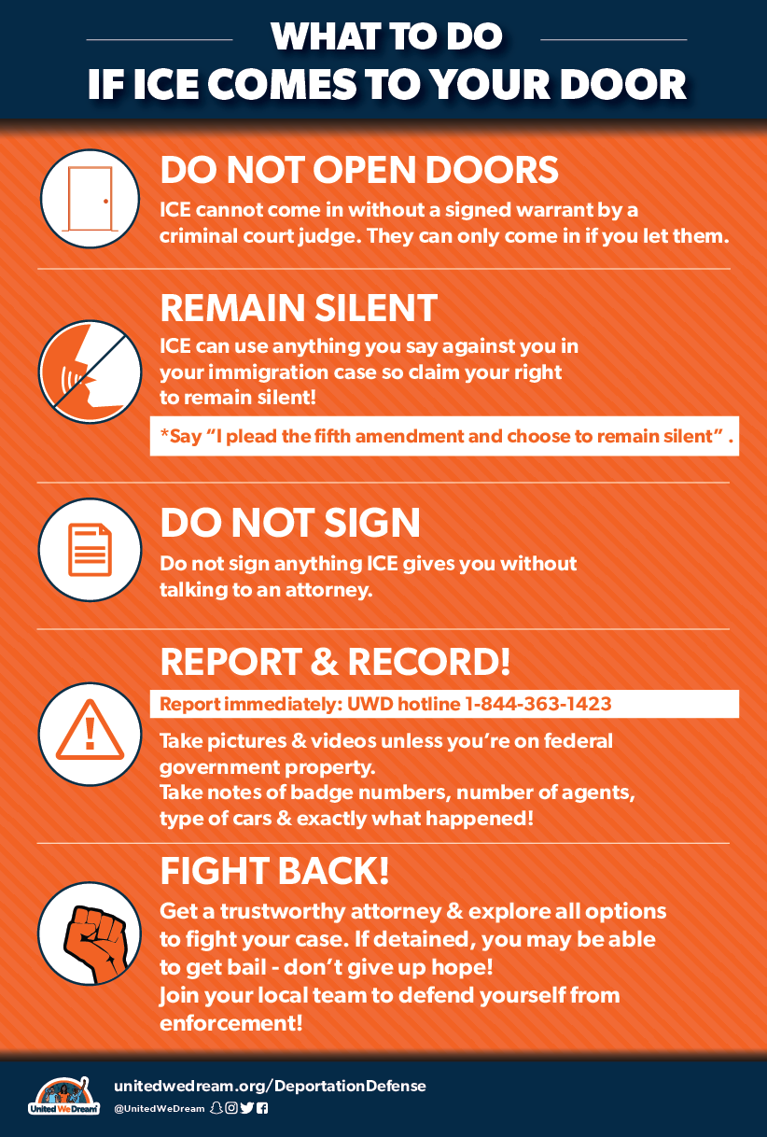
Sherri Cornett Partner, Gutfreund Cornett Art

