WHY

“It is a big question, a question of the work we have to do to eventually get to
place where there is freedom in the world. It is a huge question and it calls for a
huge answer, but that huge answer consists of small steps and we can begin
engaging in those small steps today . . . I have always discovered that it is artists
who guide us into arenas that we have not necessarily known before . . .” Angela Davis

Small steps, all steps are needed to answer the huge and vital question, “How do we create a more just and free world for ourselves and future generations?” The list of issues, projects, actions and policies responding to this question, as outlined by Dennis McDonough in his White House Blog is overwhelming:

Gender equality, race equality, marriage equality, a livable wage,
equal pay for equal work, voting rights, civil rights, reducing violence
via guns, in domestic settings, and bullying, opportunities for people
with disabilities, accessible and affordable child care, worker’s rights,
expanding early education, improving K-12 education, healthier school meals, more affordable or free college options, cradle to college-career support, retirement savings, social security, reforming wall street, job training, strengthening the relationship between the US and tribal governments, immigration reform, refugee integration, clean energy,
fuel economy standards, infrastructure, domestic manufacturing, equal
access to and affordable health care empowering patients and their
decision making, health security, veteran care, internet accessibility for
all, climate policies, criminal justice reform, increasing trust and accountability with policing, preventing and ending homelessness,
protecting consumers.

The frequency, depth and intersectionality of the stories and tragedies related to all of these can be paralyzing, especially if we consider even a portion of this complexity when we are alone. And the sub-questions can easily find us wishing to retreat further.

What can we realistically do? Can we do anything? Can we contribute anything? How do we process our emotional responses? In anger? In action? In compassion? How much compassion can we give until we, ourselves, fall apart? How do we handle change as a constant and accelerating force? How do we avoid shutting down, pretending that these issues are not our issues, “I” am not “them”? How can we be truthful about our own views? Our own responses? How do we stay open to new ideas and solutions when our heads are seemingly too full to take in any more information? How do we as a society reverse the divisiveness that comes out of this helplessness and fear? How do we make our voices heard? Our votes count? What do we tell our children? How do we protect them? How do we preserve our humanity, compassion and empathy? How do we find comfort? How do we channel the myriad emotional responses into something worthwhile, meaningful, even cathartic?

None of the answers are black/white, either/or and they take time, energy and thought. Artists have many media into which to place these emotions, to process our distress, share our concerns and implore viewers to take action. Karen and I, through our curatorial partnership Gutfreund Cornett Art, are channeling our anguish, as well as hope, into the creation of exhibitions such as Social Justice: It Happens to One, It Happens to All.

SANCTIONED SPACES FOR CONTEMPLATION AND REFLECTION

The art and museum galleries give us a permissible venue to which to process and meditate on the tragedies around us and in the larger world and to acknowledge the tensions about and visceral reactions to such horrors. A place removed from the seemingly constant barrage of bad news. These works call to us to feel, to have sympathy and empathy, to recognize our own shame, guilt, fear and anxiety and, perhaps, examine where our own perceptions need tweaking.

During the opening for our What’s Right, What’s Left: Democracy in America exhibition in January 2016, a Turkish man introduced himself to me. He was visiting his daughter, who was studying in the city and, because he was so distraught about the state of democracy or lack thereof in his country, he needed the solace of being in a safe place where democracy was being talked about and analyzed. He was not an artist but told me how comforting it was that we had that space to share our concerns and feelings about what is right and what is wrong in government. That brief conversation made the world seem like a smaller, kinder place, where strangers feel safe enough to reach out to each other for a bit of solace.

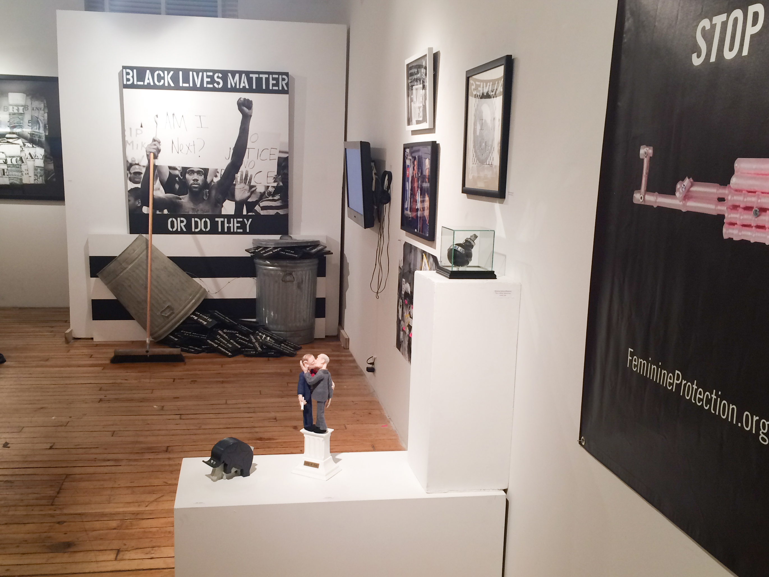
Install shot, What’s Right, What’s Left: Democracy in America

In that show and in this one, artists present us with multivariate angles from which to look at social justice issues. Some works invite us in subtly, such as Jennifer Cawley’s "For Darfur, for Sudan” while others present images not easily forgotten, such as Veronica Cardoso’s "The Girl Who Fell from the Sky/La nina que se cayo del cielo". They can startle us out of complacency and into questioning what we think we know.

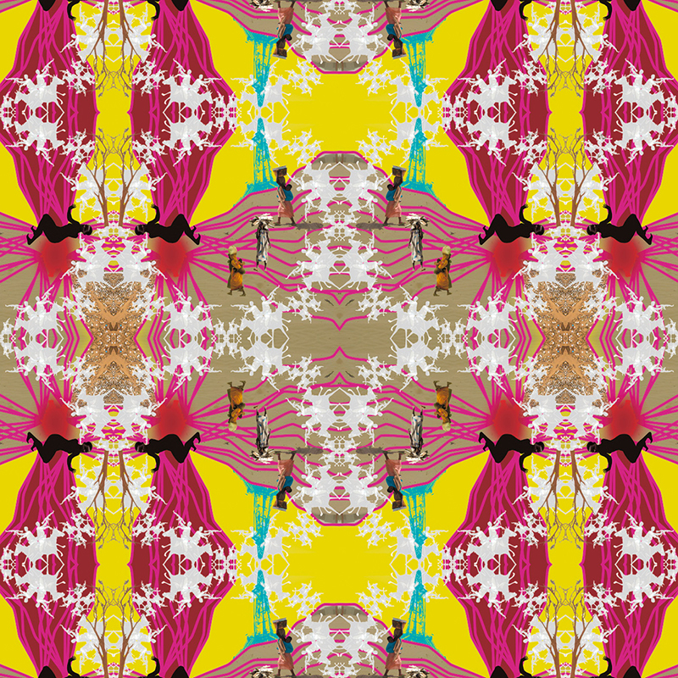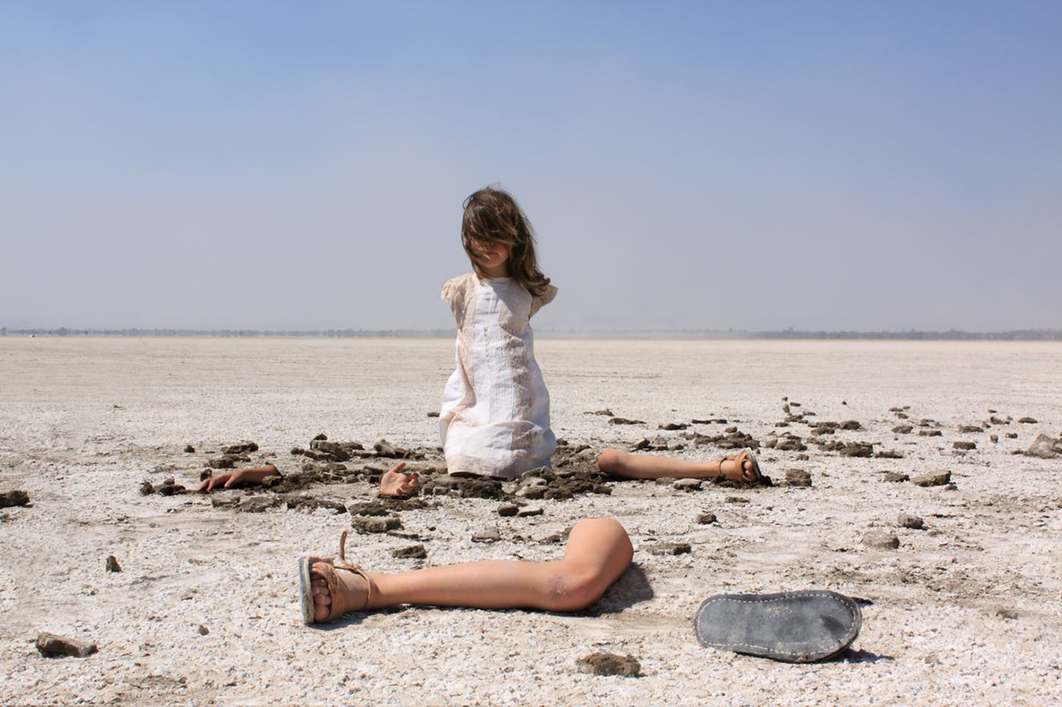
Jennifer Cawley Veronica Cardoso
"For Darfur, for Sudan” "The Girl Who Fell from the Sky/La nina que se cayo del cielo"

OPPORTUNITIES FOR DIALOG

One of the main motivators for creating these kinds of exhibitions is the dialog that is engendered by the works and the communities that form in the process of developing and participating in them. Between the artworks and the viewers, between the artists and the viewers, within groups of viewers, within groups of artists. The informal comments and reactions while viewing works with strangers and the more formal “In Conversation” gathering with the artists and audience which is planned during the opening day events of this exhibitions.

Artists have an opportunity to be part of the discourse. They are shedding light on their personal experiences with injustice or those endured by others. Viewers have the opportunity to talk about their own experience, to voice their own imperfections and reflect on those in other people and, hopefully, rediscover patience and tolerance for those imperfections as they, through this shared dialog, work together to transcend polarities and rediscover our common humanity.

CREATING COMMUNITIES

These communities may only be temporary or they might ripple outward from the gallery spaces into permanent bonds. But, they are born within the structure of activist-themed exhibitions, such as this one, and pull us back into our genetic need for connection, the comfort of a collective experience and the satisfaction of common-focused work and problem solving. They give us hope and reassurance that others in the world are concerned and evaluating and determining their next steps, along with us. They are also asking themselves and us how to best navigate through the world and be an engaged citizen. Interacting with others strengthens our beliefs in cooperation that may lead to better decision-making and policies from the local to global arenas. This sense of community can empower those least likely to speak out, to do so and to respond and take action with whatever skills and insights they have. We are creating a space from which action moves forth from these communities to larger ones. As Berthold Brecht has advised, we are showing the world it is capable of changing.

HOW DO WE KNOW ACTIVIST ART AND EXHIBITIONS HAVE VALUE AND SOCIAL IMPACT?

Centuries of contemplation of art’s value and the parameters within which we value art have certainly evolved. Socrates saw art as a mirror held up to nature. Aristotle believed art could provide a catharsis, a creation in the audience of emotions similar to those experienced when the artists created the piece. Nietsche thought of art as a way to make life more bearable.

If we look at art as a sign of Hegel’s Geist (mind, spirit, essence), the evolution of activist art is in line with where the human psyche is now, especially right now, with the potency in our society’s questioning of social justice issues. The business of being an artist, according to R. G. Collingwood, is “to explore his own emotions: to discover emotions in himself of which he was unaware, and, by permitting the audience to witness the discovery, enable them to make a similar discovery about themselves.” Peggy Phelan, writing about the political purpose of feminist art, stated that it has “something of Hegel’s aufhebung about it, a “simultaneously a lifting and renunciation . . . [and that the] ‘raising’ in consciousness-raising involves an elevation and lifting of awareness, even as it also entails a renunciation of passive acceptance, a new intolerance towards unconsidered ‘going along’.”

Viewers at these shows are asked to not look away, but to, instead, spend time seeing the sometimes disturbing and upsetting works and perhaps take unfamiliar, uncomfortable, yet courageous and important steps by talking with others about their reactions. There are personal benefits in working out concerns with others, forming solutions, and creating a sense of solidarity. Our sense of powerlessness, pessimism, regret, shame and guilt can be transformed.

Jen Delos Reyes, Executive Director of the Open Engagement Conference, which is focused on socially-engaged art, posited, “In our work it is necessary that we enact what we value and what we want to see in the world.” In fact, these annual conferences are packed with artists analyzing how they can do just that. Angela Davis, a keynote speaker at the 2016 Open Engagement Conference, told us, “Nina Simone devoted her art to struggle. The power of art, the art of power can decolonize our minds . . . “

I have seen this power of art. As the Chair of the International Caucus of the Women’s Caucus for Art, I attended United Nations conferences where art was embraced as a way to present and create an entry point for difficult issues in ways that circumvent language and cultural barriers. Women artists in northern China, while participating in an exhibition and presentations of socially-engaged art projects that I directed with a team of U.S.-based women artists in 2014, shared, in interviews, how seemingly simple actions and reactions, by Western standards, to these events became powerful motivators to think more broadly about issues of identity, equality, domestic violence and rape and encouraged them to speak up and out in the future.

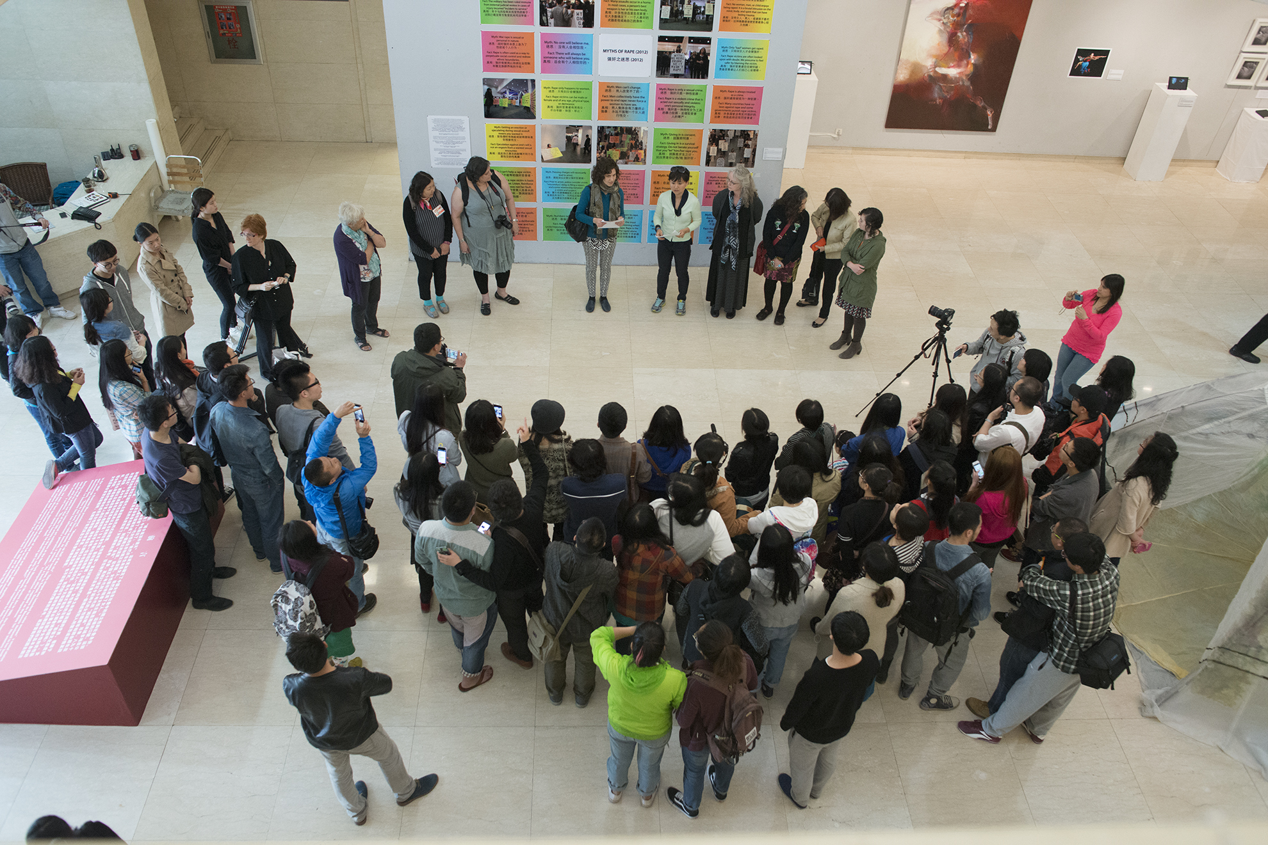
“Myths and Facts of Rape” Call and Response
during Half the Sky: Intersections in Social Practice Art
Luxun Academy of Fine Arts, Shenyang, China, 2014

WHERE DO WE GO FROM HERE?

Reach out.
Overcome that urge to hide and retreat.
Seek out community.
Visit museums.
Bring children to these kind of politically amplified exhibitions. Listen to their reactions.
Create a space for children to be curious, where they can be understood and learn to understand others.
Don’t assume every public official will ignore you. Call them, write them, email them with your concerns and your art.
Create art that channels your reactions and emotions.
Create art that motivates viewers to make changes in their lives and communities, to do an act of kindness, to volunteer, to step up politically and create their own art and events.
Recognize the transformative power of your experiences channeled through art.
Take small steps. Or even magnificent ones.

Sherri Cornett
Partner, Gutfreund Cornett Art

Angela Davis, Keynote speech, Open Engagement Conference, Oakland, California, May 1, 2016.
Denis McDonough, “Back to Work: What Comes After the President’s Final State of the Union Address,” blog, January 12, 2016, https://www.whitehouse.gov/blog/2016/01/12/back-work-what-comes-after-presidents-final-state-union-address, accessed July 28, 2016.
R. G. Collingwood, “The Principles of Art.” In The Nature of Art: An Anthology, ed. Thomas E. Wartenberg, (Thomson Wadsworth, 2007), 133. Originally published in R. G. Collingwood, The Principles of Art, (Oxford University Press, 1938
Peggy Phelan, “Survey,” in Art and Feminism, ed. Helena Reckitt, (Phaidon Press, 2002), 34.
Jen Delos Reyes, April 23, 2016, blog post “The Power of Love”, http://openengagement.info/jen-delos-reyes-the-power-of-love/
Angela Davis, Keynote speech, Open Engagement Conference, Oakland, California, May 1, 2016.

