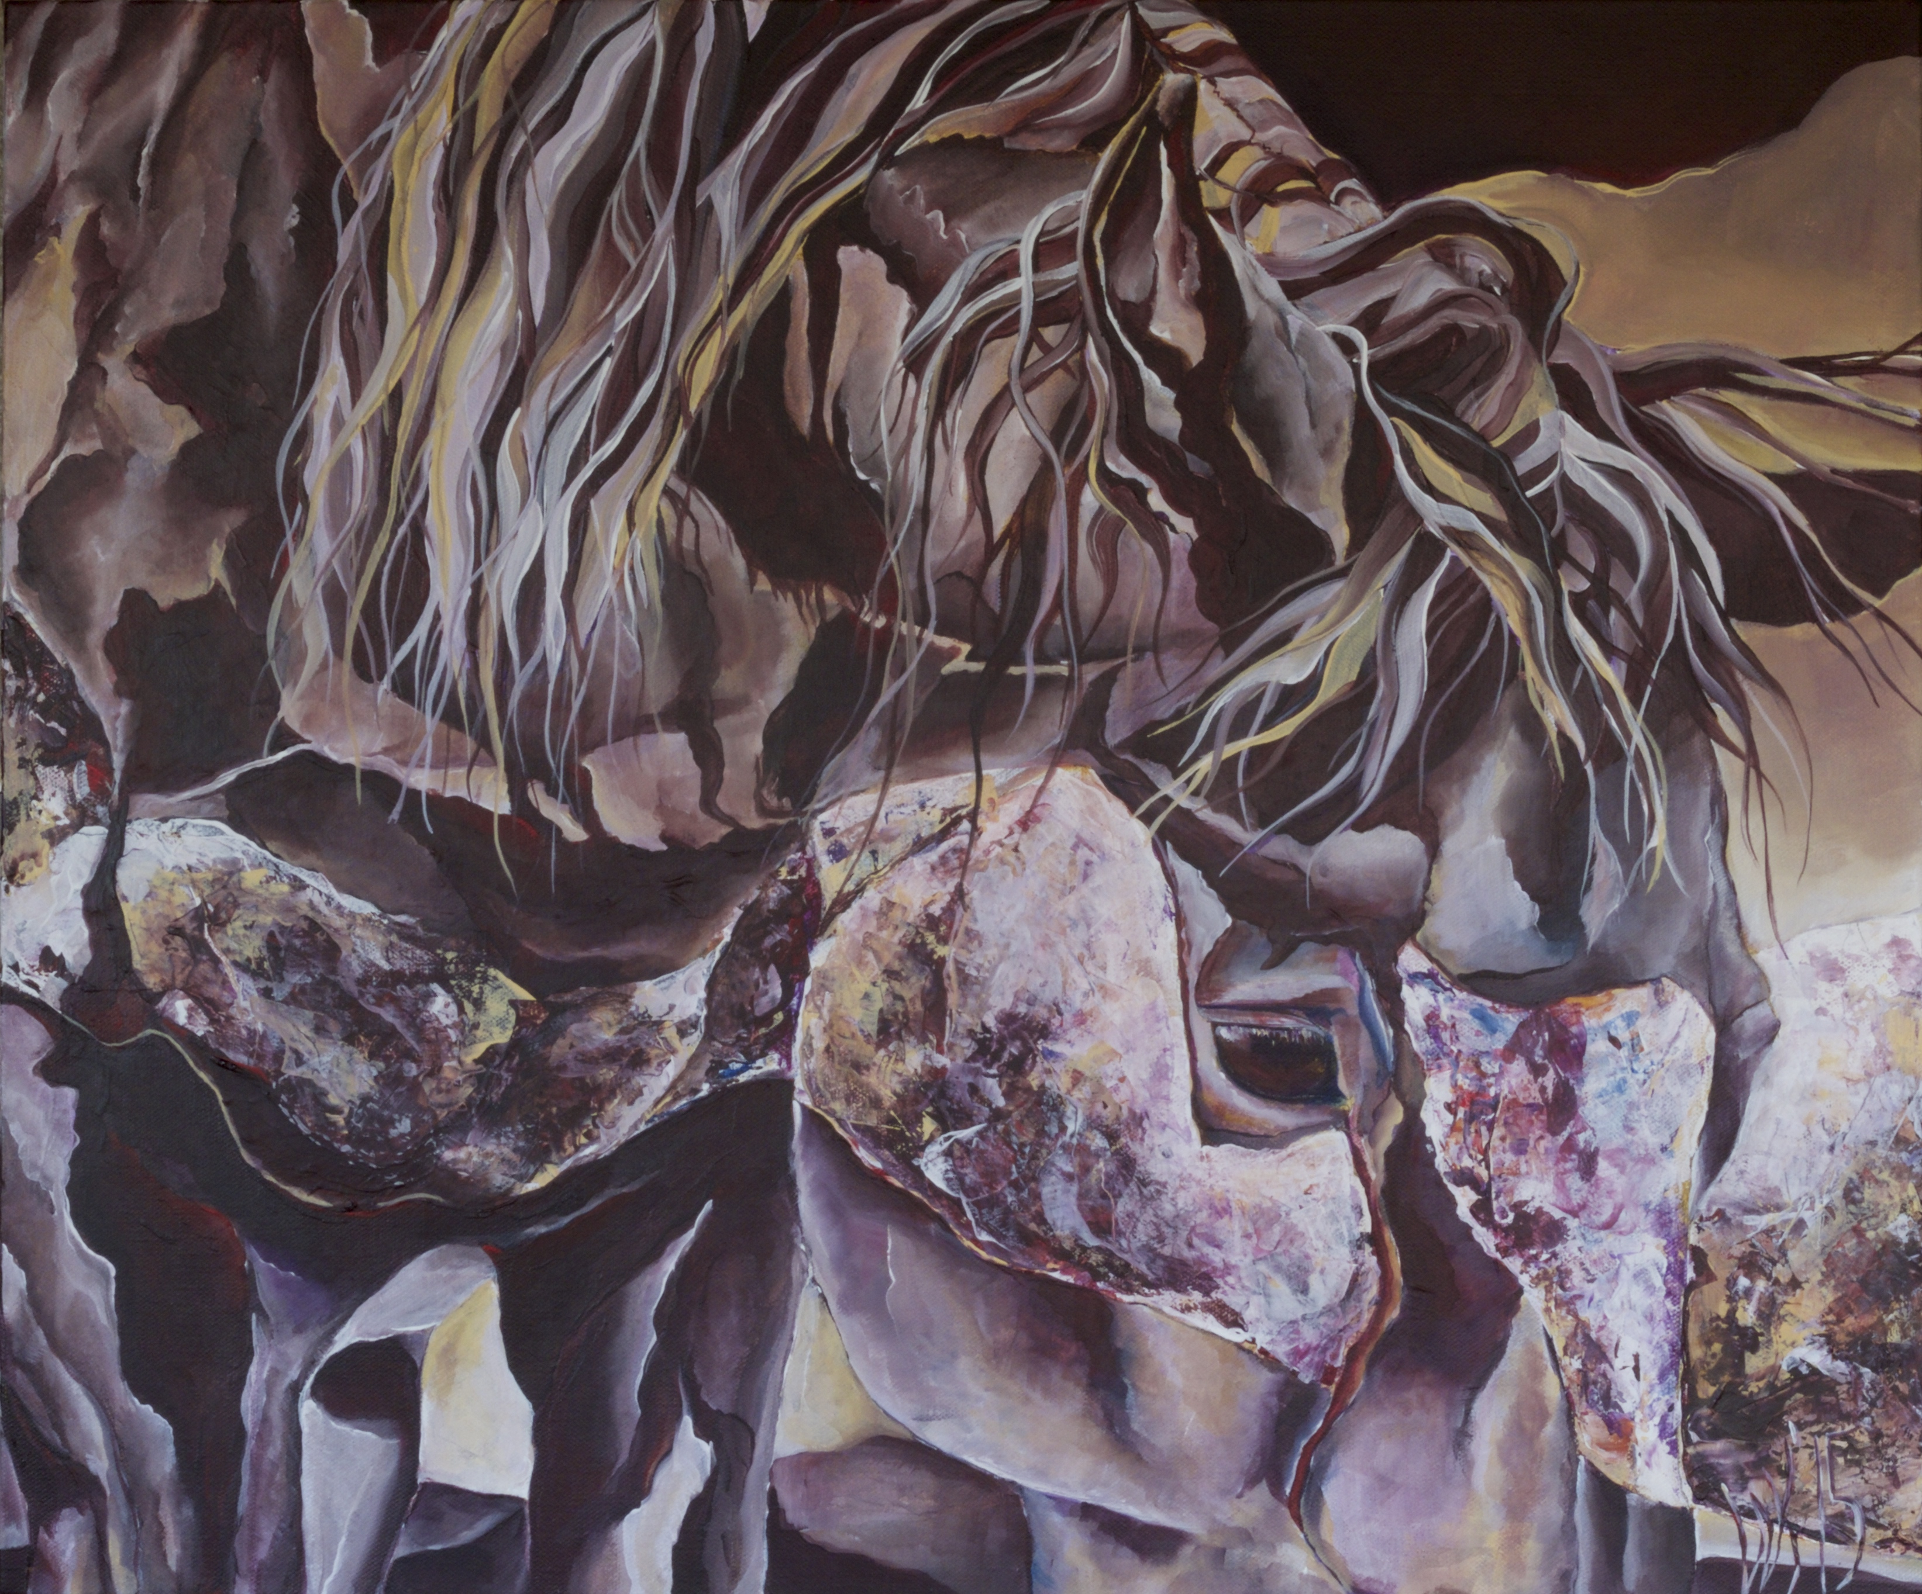
Whitney Kimpton
“Shadows; Rivulets of Tranquility”

When I approach a painting it is with the understanding that it is not only my hand that is creating the piece, but also the subject and its complex histories and the moment in which I work. Each entity breathes its own influence into the art. This entanglement of art and life is the nature of my work. It is with great respect that I step into each encounter, and with great excitement and appreciation that I inhabit each painting.

